AWS Solutions Architect – Associate

An IAM user with full administrator access can perform almost all AWS tasks except a few tasks designated only for the root account user. Some of the AWS tasks that only a root account user can do are as follows: change account name or root password or root email address, change AWS support plan, close AWS account, enable MFA on S3 bucket delete, create Cloudfront key pair, register for GovCloud.

IAM – MFA ability, Identity Federation/Active Directory (SAML)

SQS message timers postpone the delivery of certain messages to the queue up to 15 minutes

NLB – IPs are exposed which allows you to white/blacklist

Security Groups

Security groups can be pinged

1. By default allow all outbound traffic.

2. Security group rules are always permissive; you can't create rules that deny access.

3. Security groups are stateful

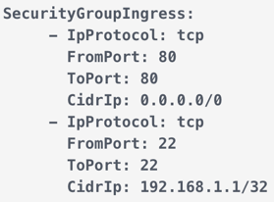

**It allows any IP to pass through on the HTTP port**

**It configures a security group's inbound rules**

**It lets traffic flow from one IP on port 22**

EC2 – instances billed by second; t2.micro is free; Linux/Mac use SSH – Windows use Putty

Timeout issues -> security group issues

SSH port is 22

Permission issues on SSH key -> run ‘chmod 0400’

CloudWatch alarms actions can automatically stop, terminate, reboot, or recover your EC2 instances.

**A recovered instance is identical to the original instance**

**If your instance has a public IPv4 address, it retains the public IPv4 address after recovery**

Install a CloudWatch Logs agents on the EC2 instances to send logs to CloudWatch

By default, cross-zone load balancing is enabled for Application Load Balancer and disabled for Network Load Balancer

Cross zone enabled – distribute evenly across instances (all have same percentage of traffic); disabled – distributed evenly across zones

Default rules for a default security group: Allow inbound traffic from network interfaces (and their associated instances) that are assigned to the same security group. Allows all outbound traffic

Default rules for security group that you create: Allows no inbound traffic Allows all outbound traffic

SPOT instances

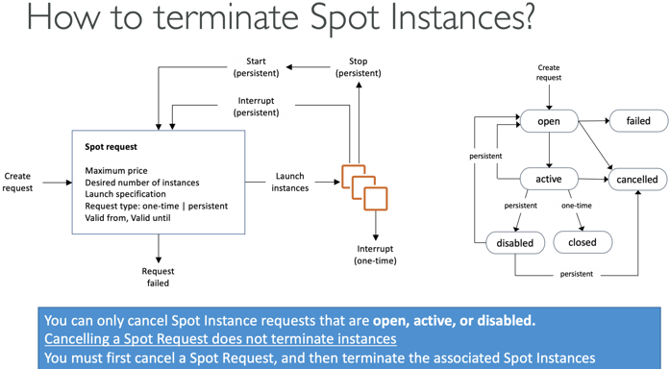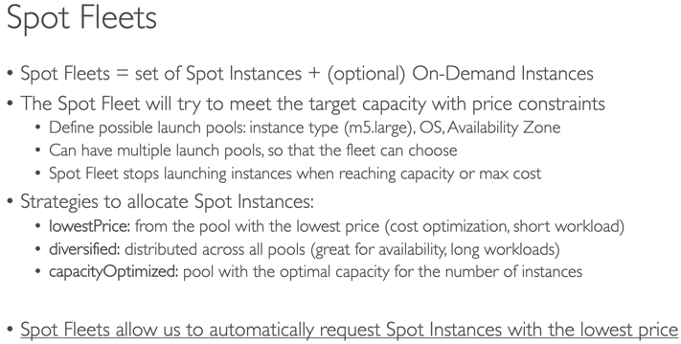

If current spot price > your max price you can choose to stop or terminate your instance with a 2 minutes grace period.

If a spot request is persistent, then it is opened again after your Spot Instance is interrupted

Other strategy: **Spot Block** - “block” spot instance during a specified time frame (1 to 6 hours) without interruptions

Instance Types

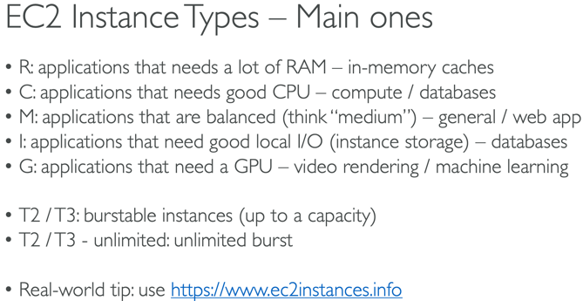 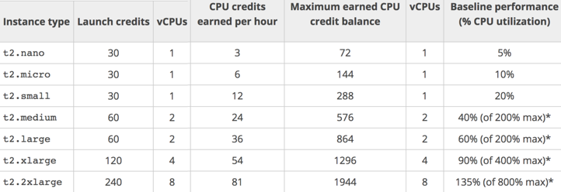

ECS with EC2 launch type is charged based on EC2 instances and EBS volumes used.

Fargate is charged based on vCPU and memory resources that the containerized application requests

AMI – image to create instances for Linux or Windows machines

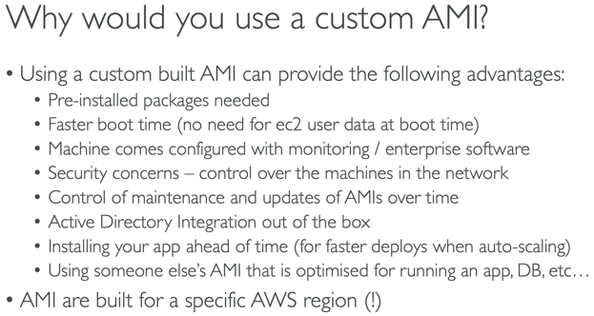 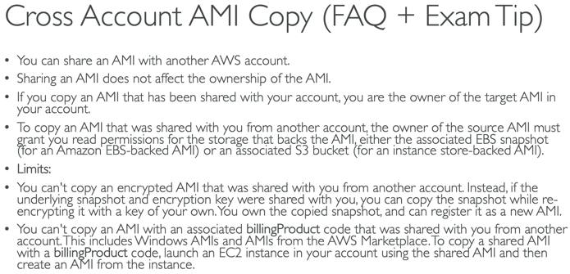

* AMIs can be found and published on Amazon MarketPlace
* AMIs stored in S3 (but not seen in S3 Console); cheap storage
* By default they are private but can be made public to share with other accounts
* Can be copied across regions, accounts

When a new AMI is copied from region A into region B, it automatically creates a snapshot in region B because AMIs are based on the underlying snapshots.

Placement Groups

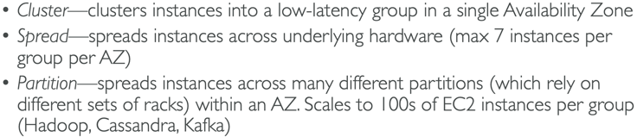

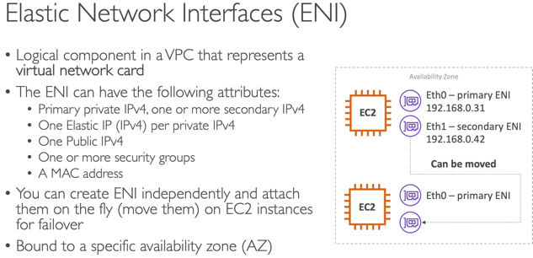

Instances can be stopped and terminated

First start – OS boots up and EC2 User Data is run; following starts the OS boots up, app starts, caches warms up – which all take time

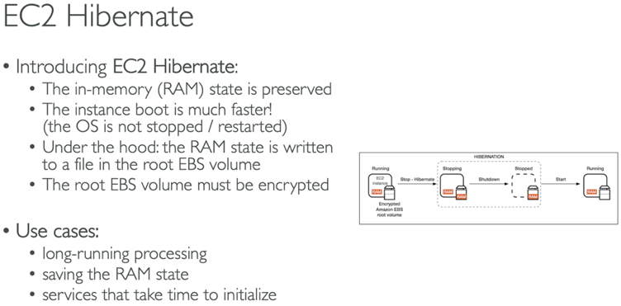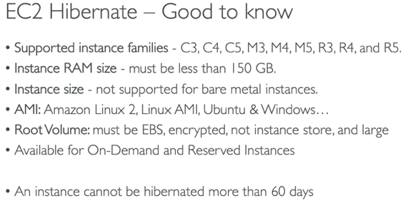

Auto Scaling Groups

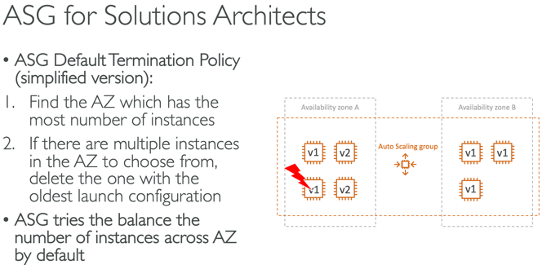 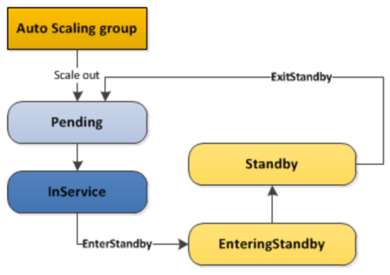

The **ReplaceUnhealthy** process type terminates instances that are marked as unhealthy and then creates new instances to replace them.

When **rebalancing**, Amazon EC2 Auto Scaling launches new instances before terminating the old ones, so that rebalancing does not compromise the performance or availability of your application.

However, the **scaling activity** of Auto Scaling works in a different sequence compared to the rebalancing activity. Auto Scaling creates a new scaling activity for terminating the unhealthy instance and then terminates it. Later, another scaling activity launches a new instance to replace the terminated instance.

Increase the deregistration delay so users do not see their current requests interrupted

Defaults: AWS management console - basic monitoring; AWS CLI – detailed monitoring

To control whether an Auto Scaling group can terminate a particular instance when scaling in, use instance scale-in protection.

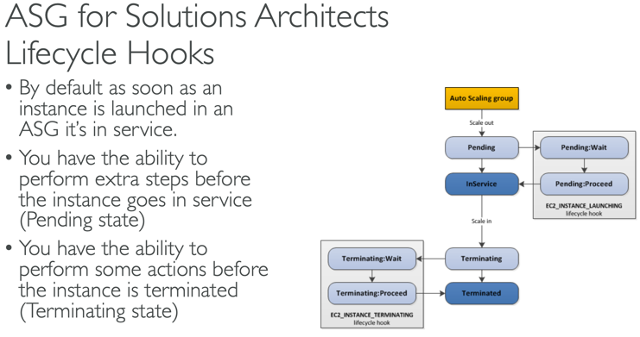 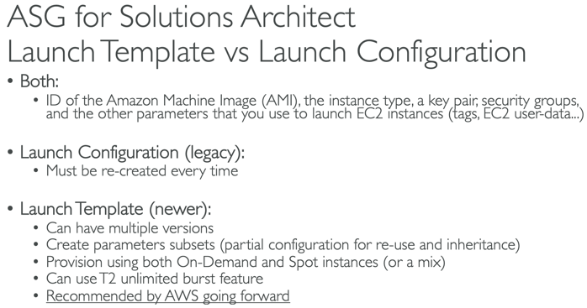

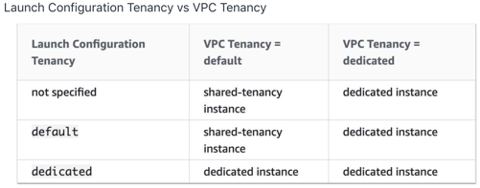

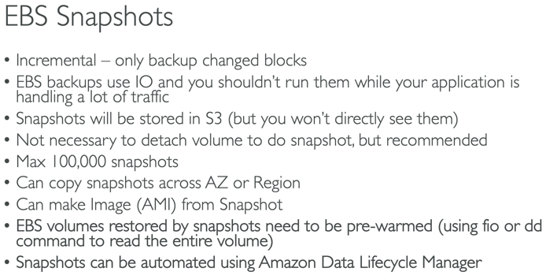 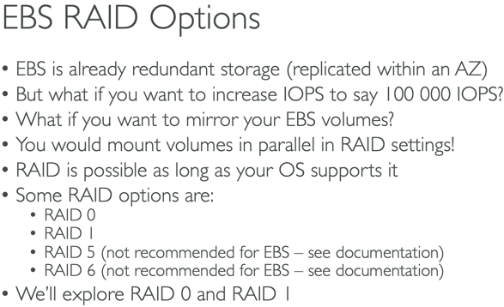

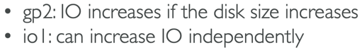

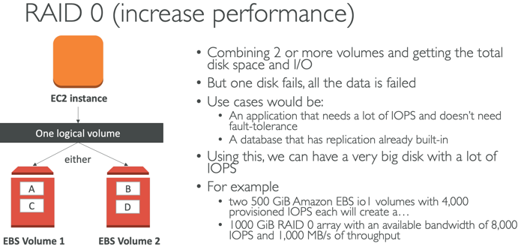 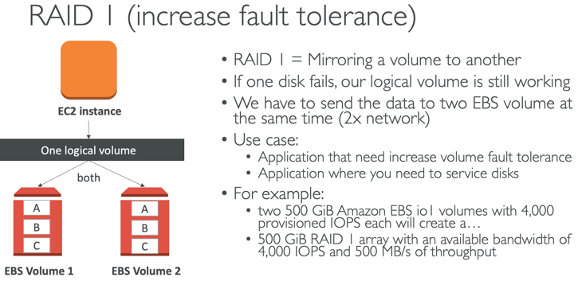

EBS volumes are attached locally to the EC2 instances, Therefore uploads (ie:videos) are tied to specific EC2 instances if using high availability/ELB. Every time the user logs in, they are directed to a different instance and therefore their videos get dispersed across multiple EBS volumes. The correct solution is to use either S3 or EFS.

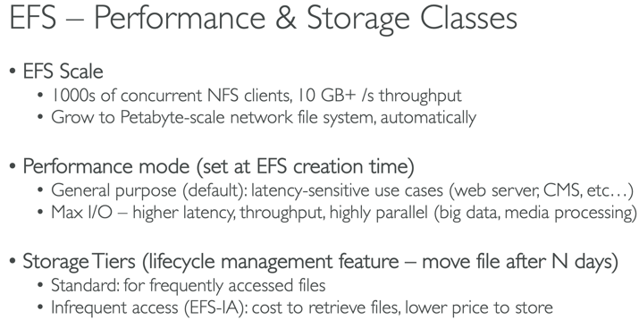

EFS – only for Linux, not Windows; more expensive than EBS

You can connect to Amazon EFS file systems from EC2 instances in other AWS regions using an **inter-region VPC peering connection**, and from on-premises servers using an AWS VPN connection.

You can't mount a network file system on S3 Intelligent Tiering as it's an object storage service

5 architecture pillars: costs, performance, reliability, security, operational excellence

A Stateless app is an application program that does not save client data generated in one session for use in the next session with that client (ie: not using a database). A Stateful application saves data about each client session and uses that data the next time the client makes a request.

**API Gateway** – stateless; **WebSocket** - stateful

Storing Session Data w/Web App

* Load balancer stickiness (session affinity), user cookies, server session (Elasticache/ DynamoDB)

Storing User Data w/Web App

* database (RDS) – scale reads with Read Replicas or with a Write Through approach using Elasticache

Disaster Recovery – replicate Elasticache and RDS across multiple availability zones

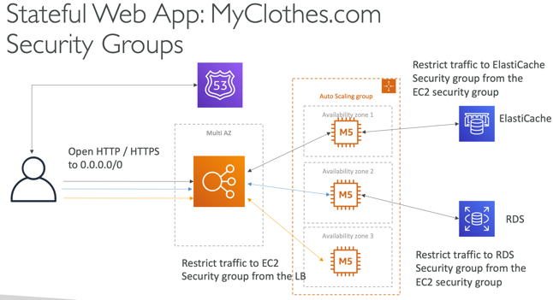

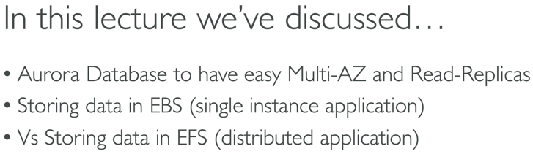

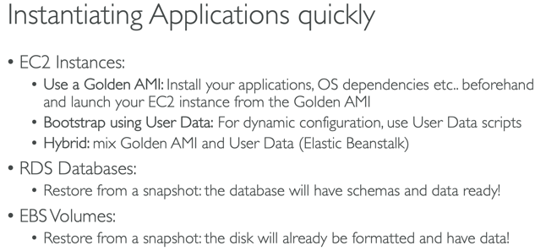 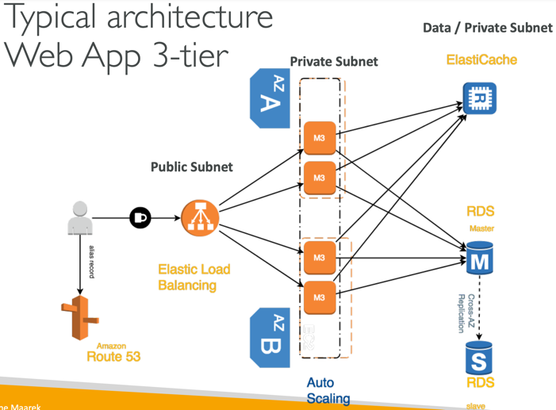

Create a Golden AMI with the **static** installation components already setup

Use EC2 user data to customize the **dynamic** installation parts at boot time

Global Users

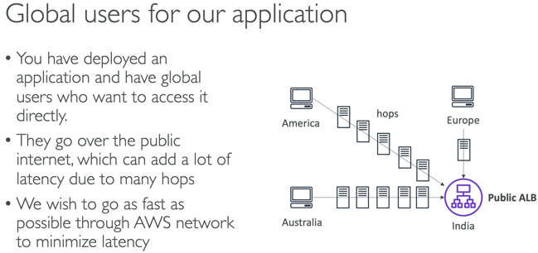 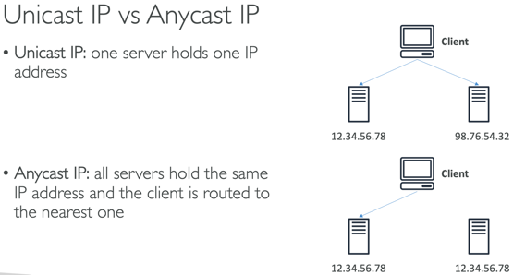

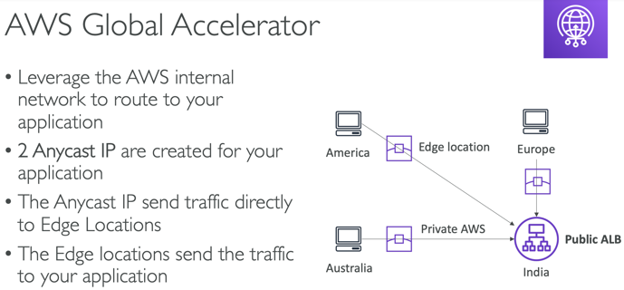 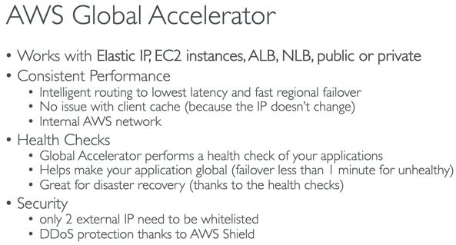

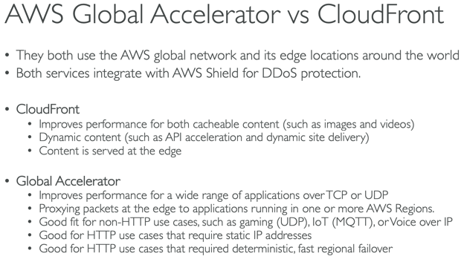

Snowball Family

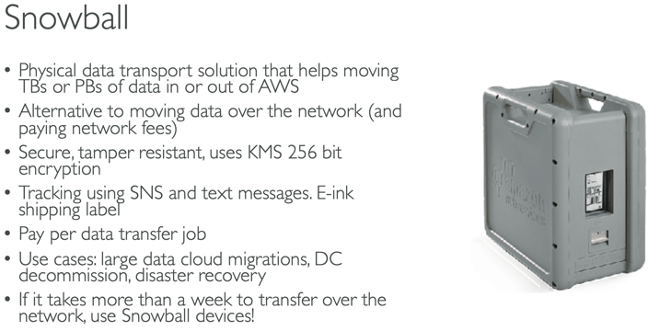 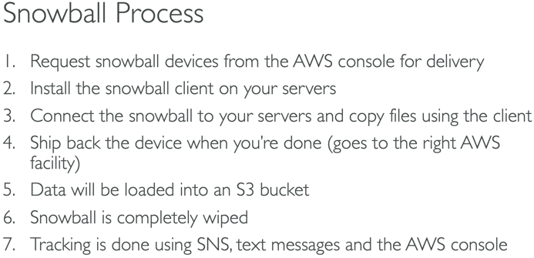

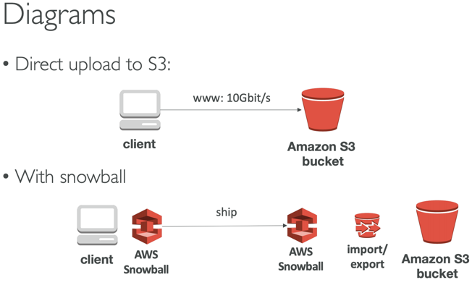 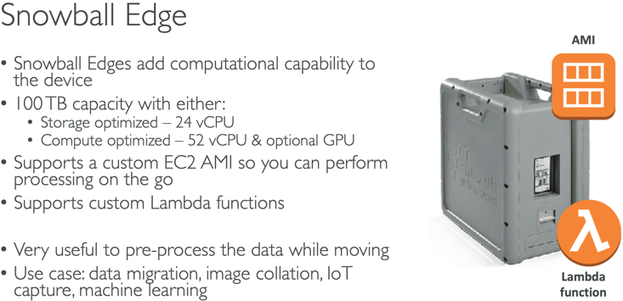

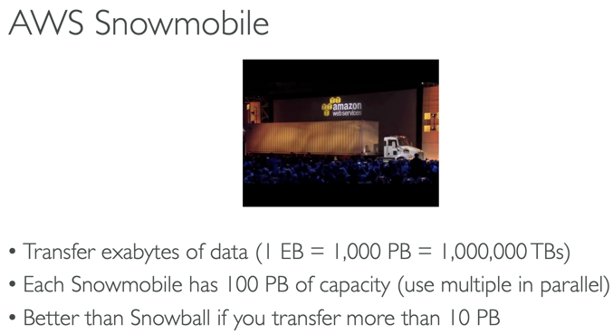 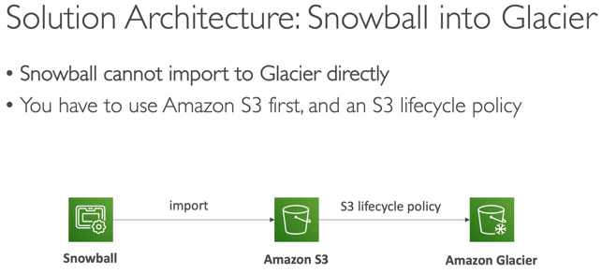

Storage Gateway

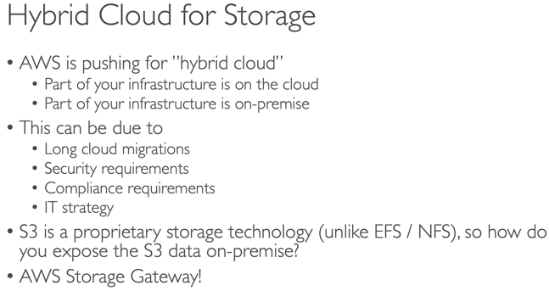 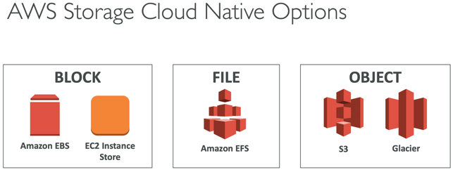

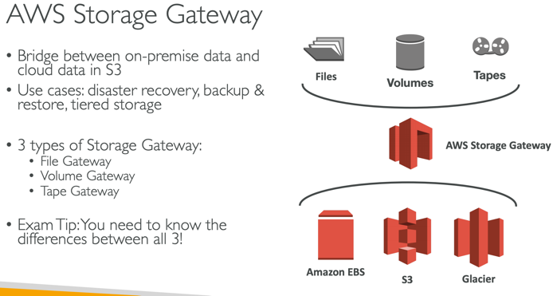 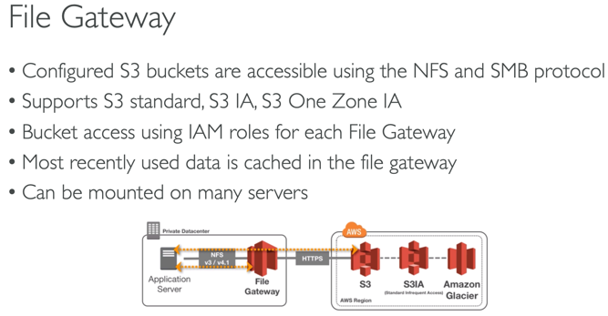

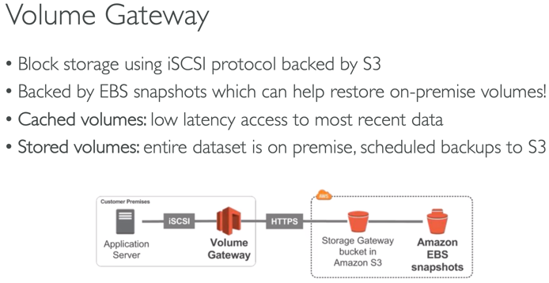 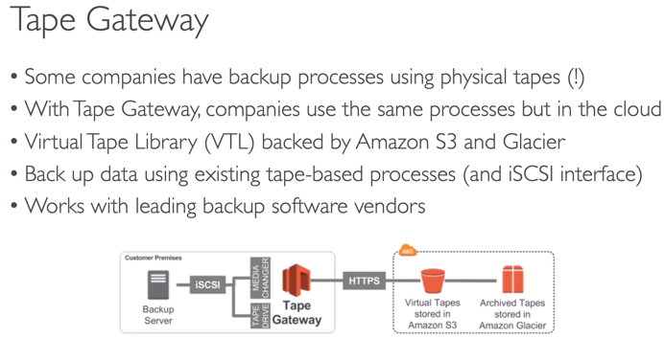

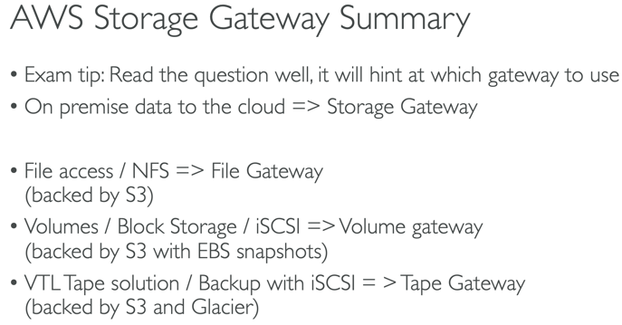 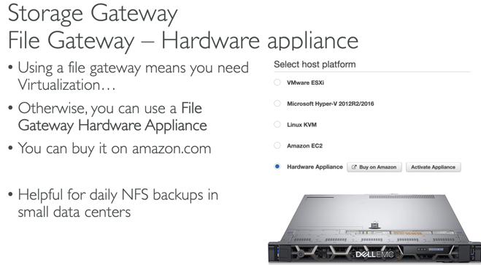

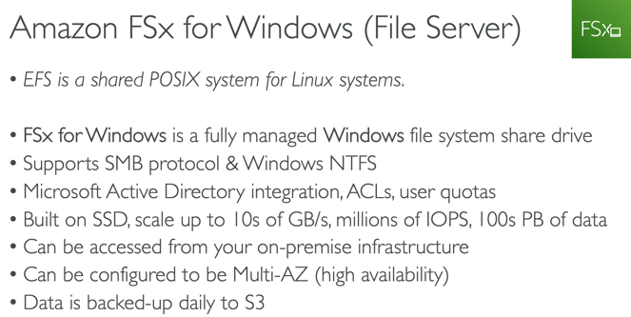 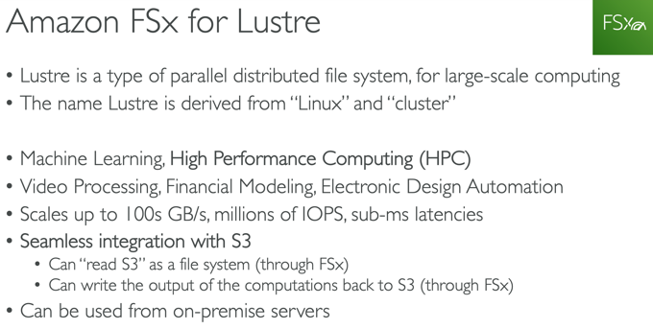

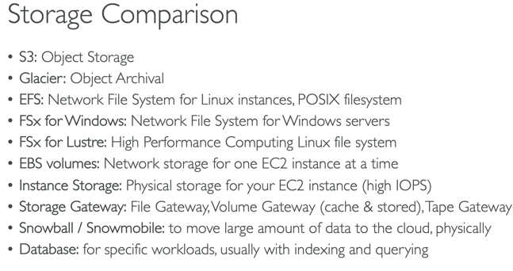 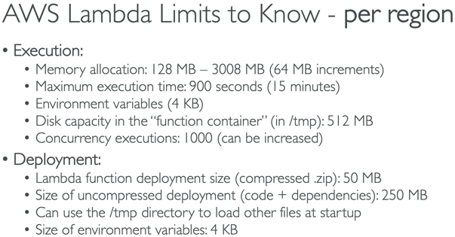

Kinesis

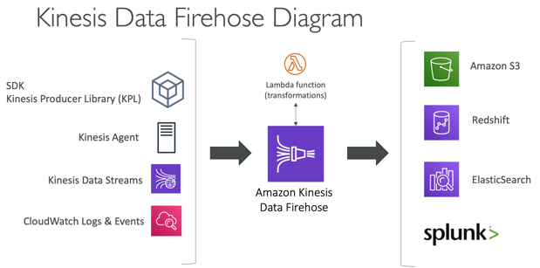

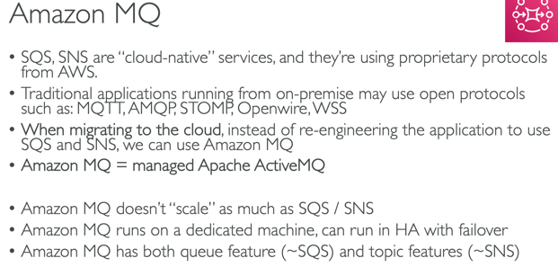 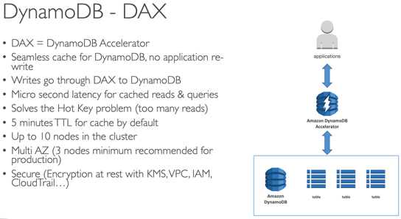

Serverless Models

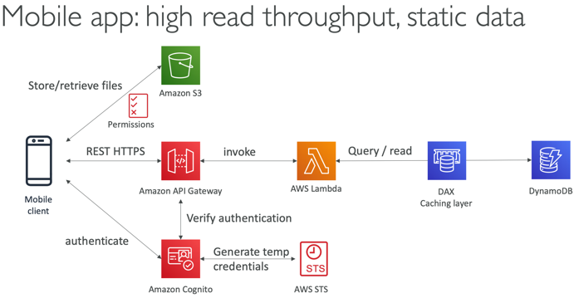 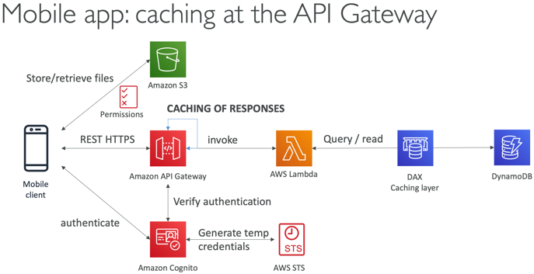

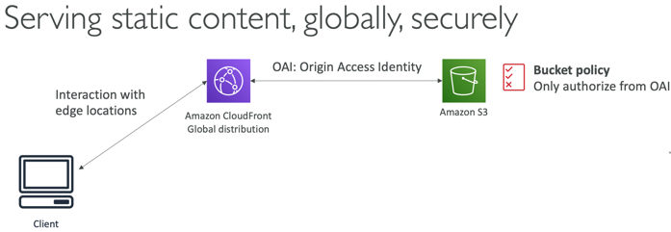 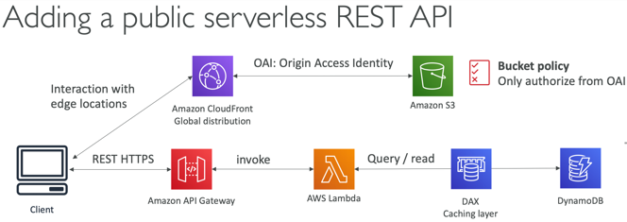

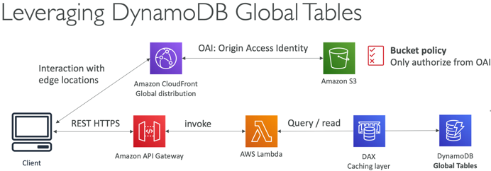

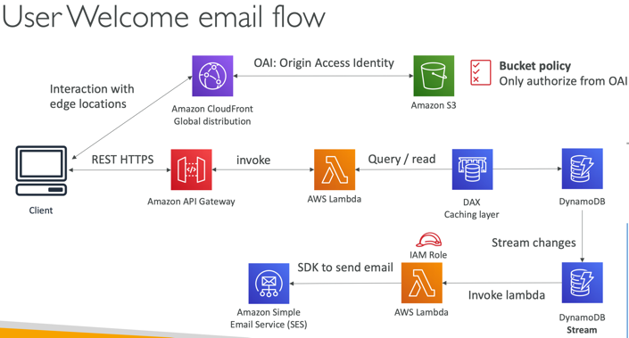 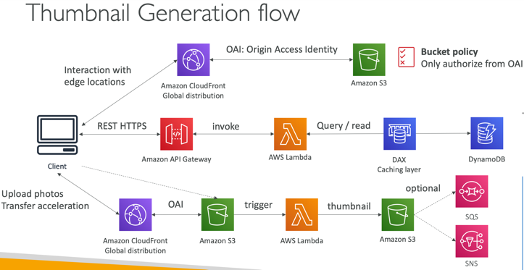

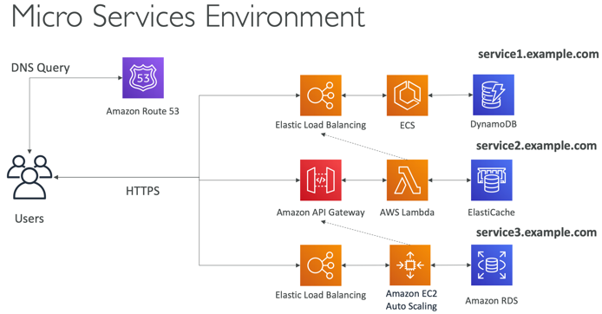 

Distributing Paid Content

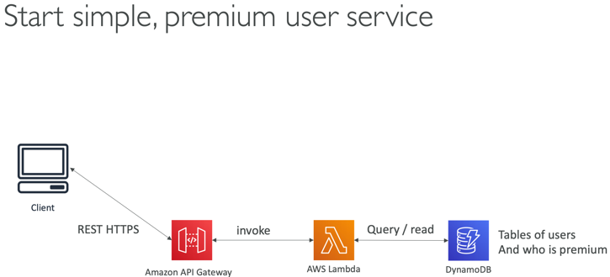 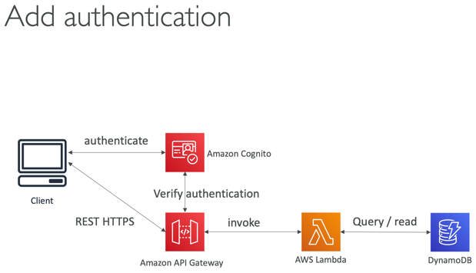

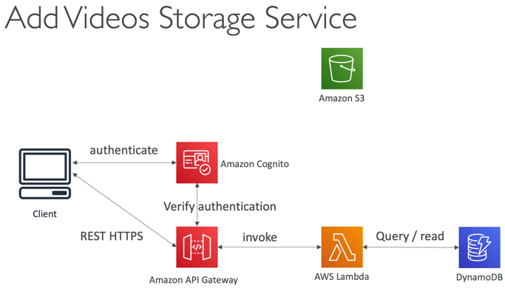 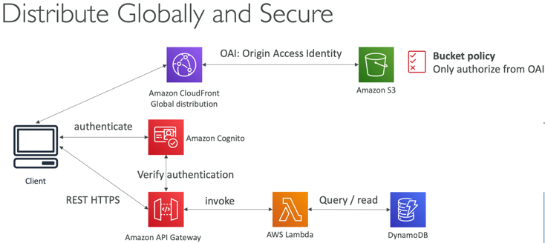

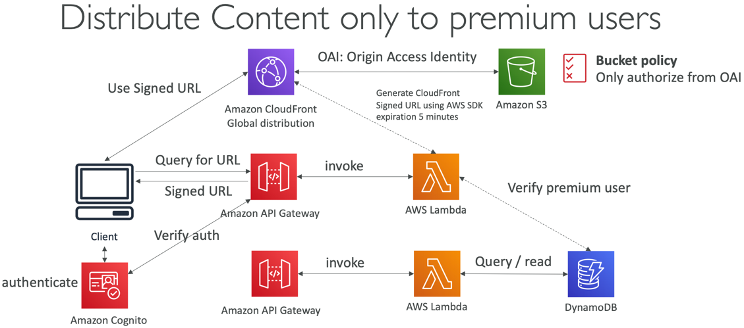

EC2 App that distributes software updates

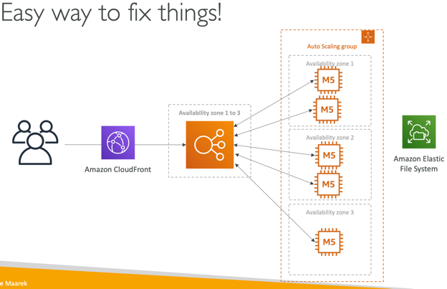 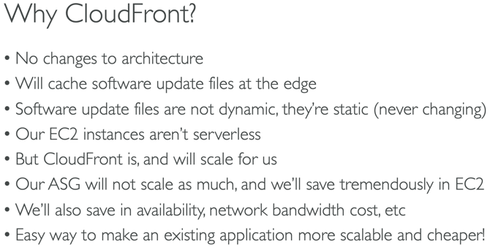

Big Data Ingestion Pipeline – Serverless, real time, data transformation

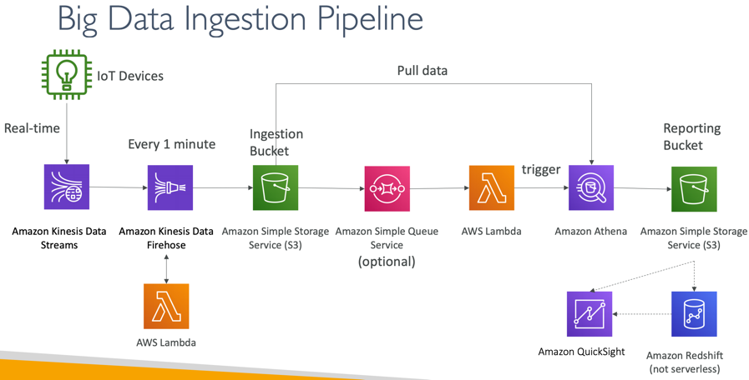 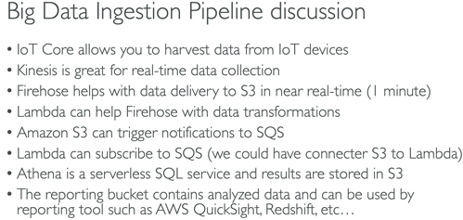

Multi-AZ - synchronous replication; Read replicas - asynchronous replication

Kinesis Agent cannot write to a Kinesis Firehose where the delivery stream source is already set as KDS

Databases

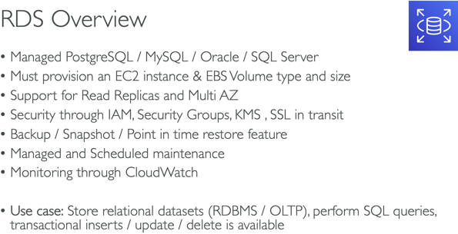 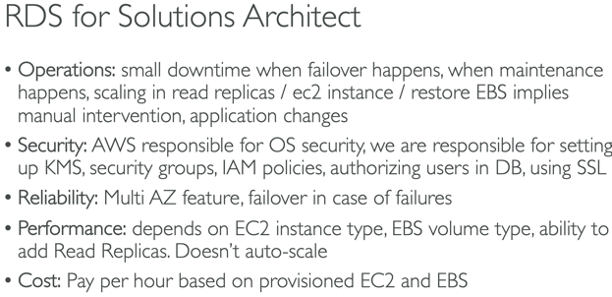

If master is not encrypted then read replicas can NOT be encrypted

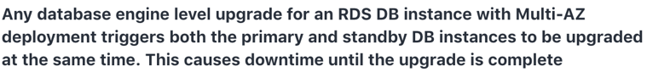

When the primary db instance goes down the CNAME record will be updated to point to the standby DB

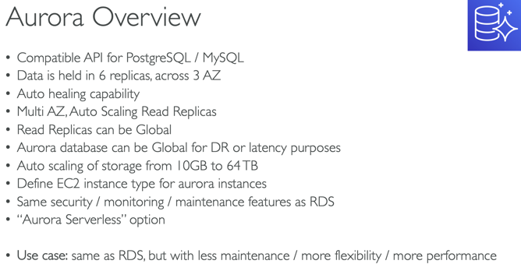 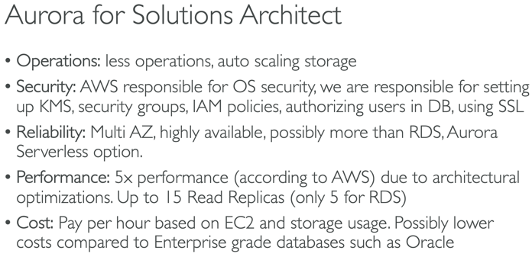

Aurora costs more than RDS, but is more efficient

For Amazon Aurora, each Read Replica is associated with a priority tier (0-15). In the event of a failover, Amazon Aurora will promote the Read Replica that has the highest priority (the lowest numbered tier). If two or more Aurora Replicas share the same priority, then Amazon RDS promotes the replica that is largest in size.

Aurora Serverless is the perfect way to create a database that can scale down to 0 servers, and scale up to many servers, as an OLTP (relational) database.

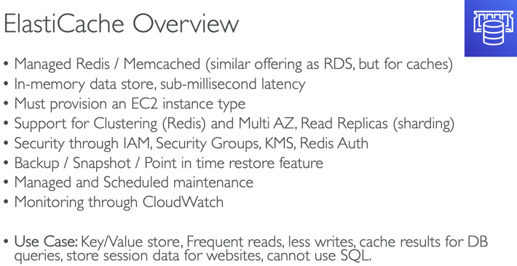 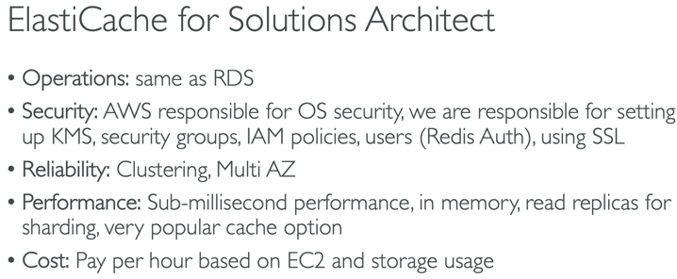

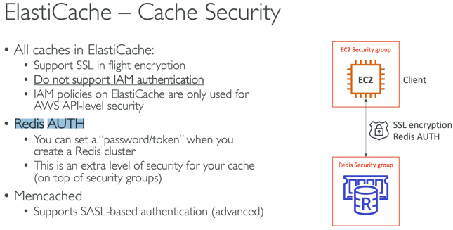

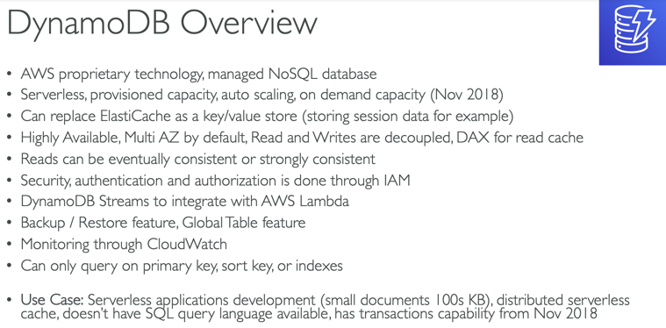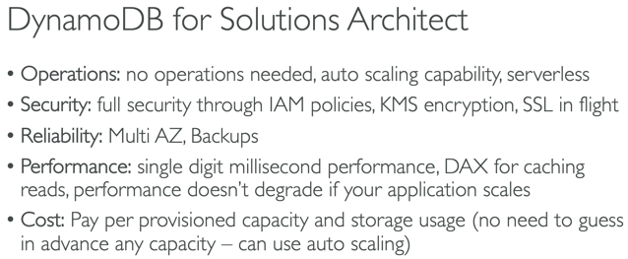

Postgres port - 5432

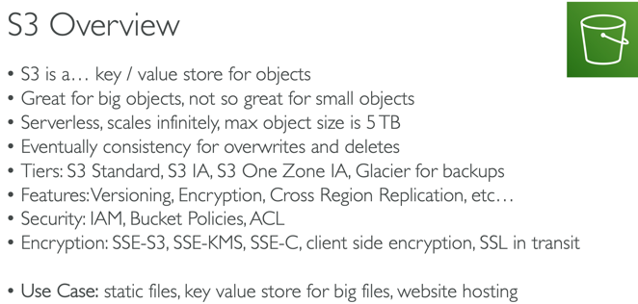 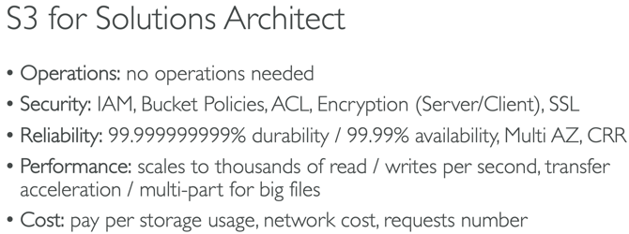

There are no limits to the number of prefixes in a bucket. You can increase your read or write performance by parallelizing reads. For example, if you create 10 prefixes in an Amazon S3 bucket to parallelize reads, you could scale your read performance to 55,000 read requests per second. Please see this example for more clarity on prefixes: if you have a file f1 stored in an S3 object path like so s3://your_bucket_name/folder1/sub_folder_1/f1, then /folder1/sub_folder_1/ becomes the prefix for file f1.

Transfer Acceleration is compatible with multi-part upload

There are **no** S3 data transfer charges when data is transferred in from the internet. Also with Transfer Acceleration, you pay **only** for transfers that are accelerated.

**Glacier supports encryption by default in transit and at rest; you can store Archives of sensitive data in Vaults and use a lock policy

S3 Cross Region Replication – great for **dynamic** content at low latency in few regions

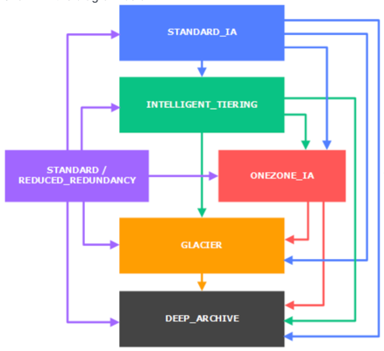

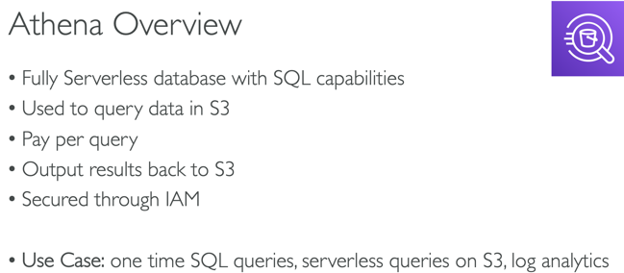 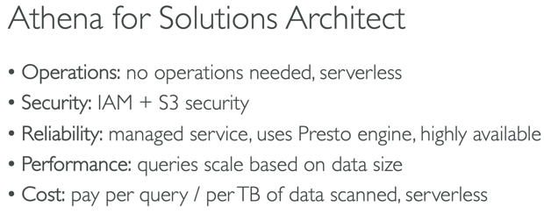

Use case: Analyze cold/infrequent used data with Athena

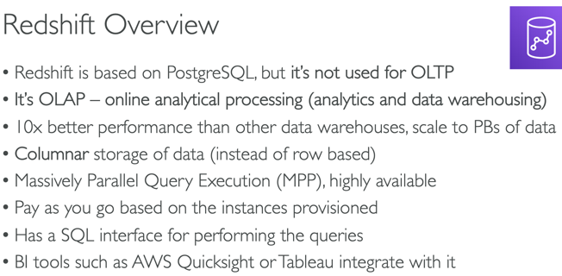 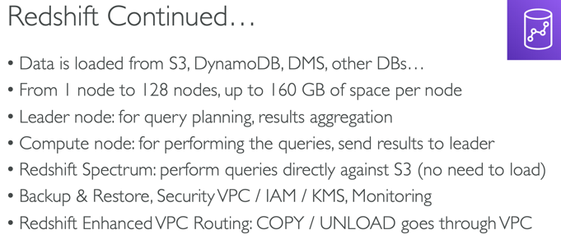

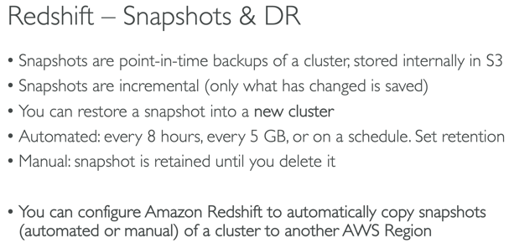 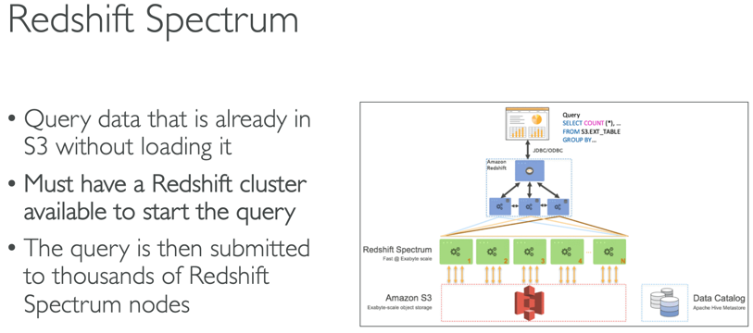

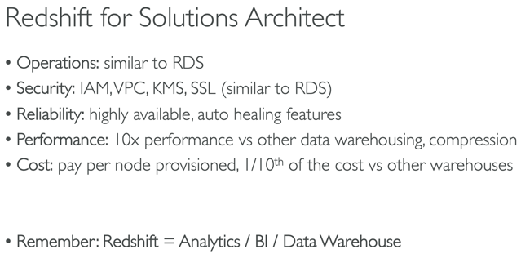

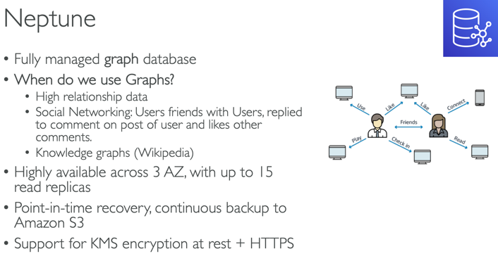 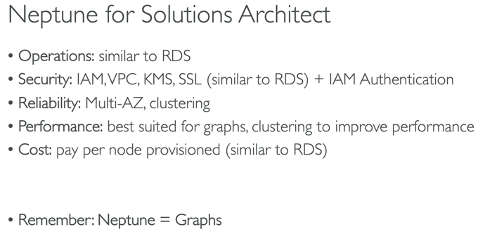

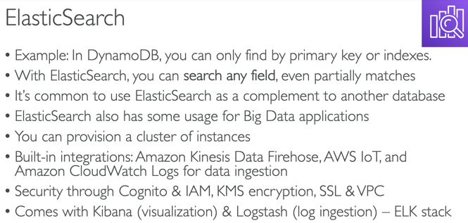 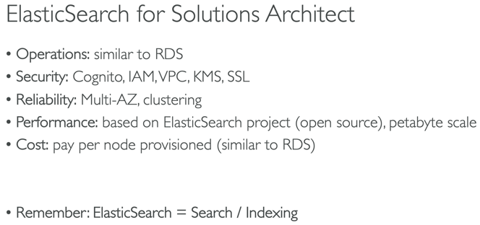

CloudWatch Logs Insights (new – Nov 2018) can be used to query logs and add queries to CloudWatch Dashboards

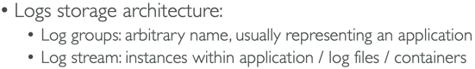

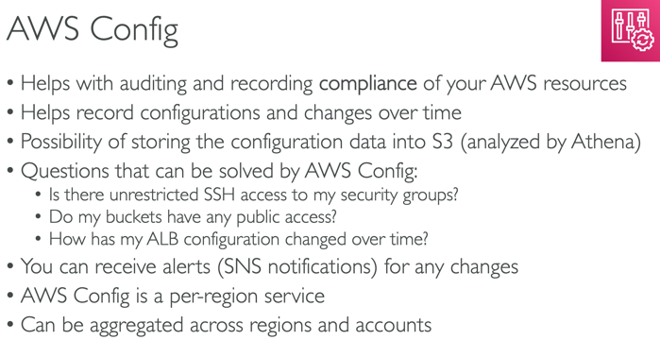 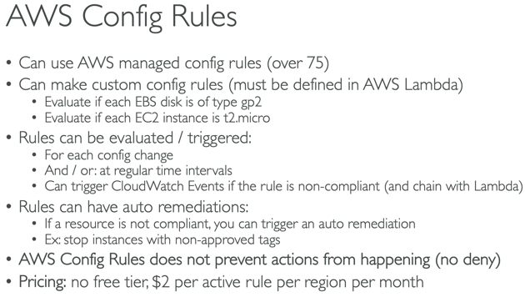

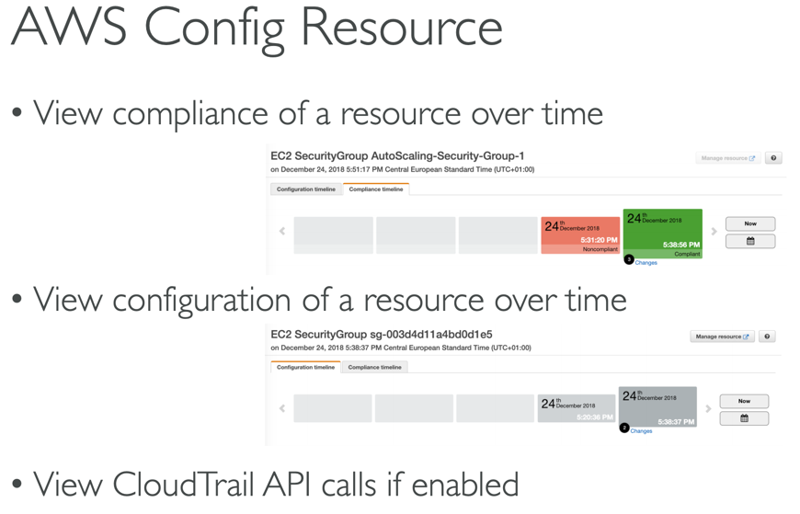

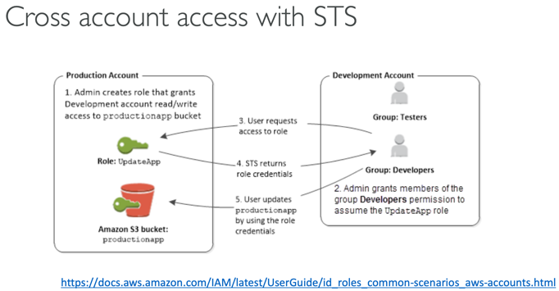

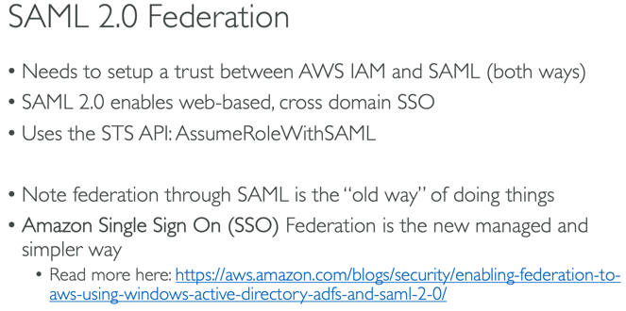

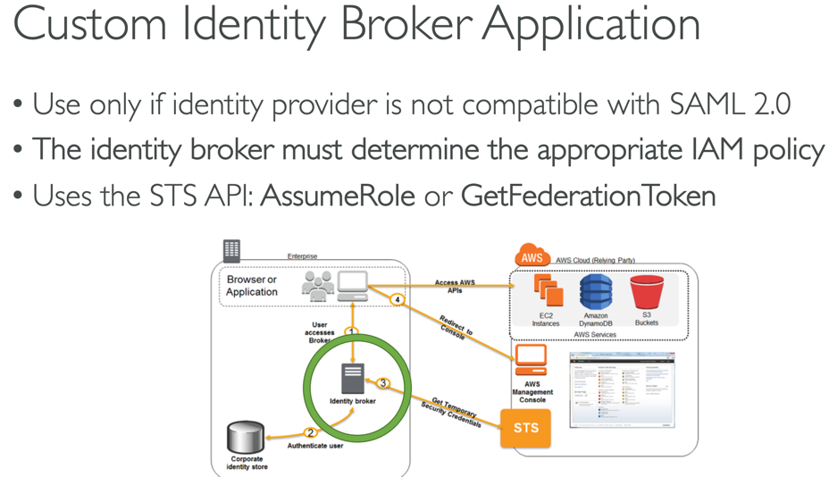

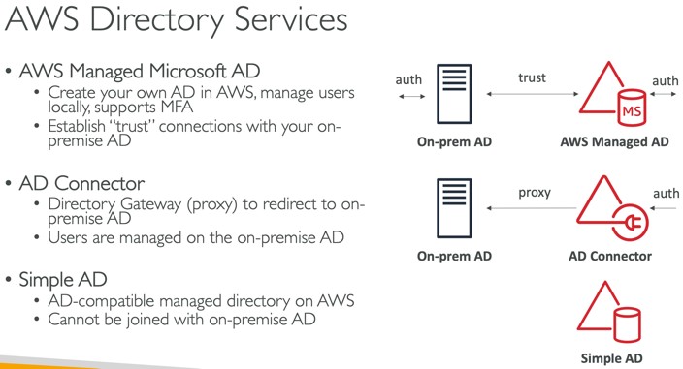

You may see questions on choosing "AWS Managed Microsoft AD" vs "AD Connector" vs "Simple AD" on the exam. Just remember that you should use AD Connector if you only need to allow your on-premises users to log in to AWS applications with their Active Directory credentials. AWS Managed Microsoft AD would also allow you to run directory-aware workloads in the AWS Cloud. AWS Managed Microsoft AD is your best choice if you have more than 5,000 users and need a trust relationship set up between an AWS hosted directory and your on-premises directories. Simple AD is the least expensive option and your best choice if you have 5,000 or fewer users and don’t need the more advanced Microsoft Active Directory features such as trust relationships with other domains.

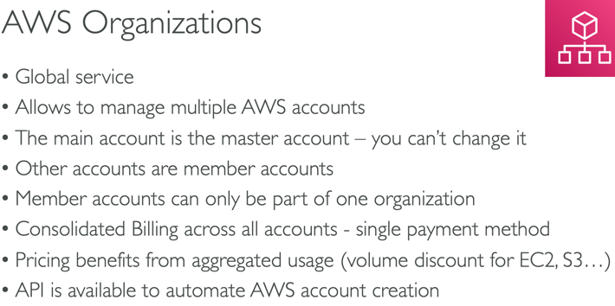 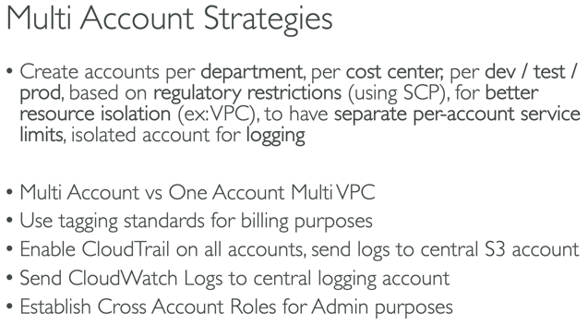

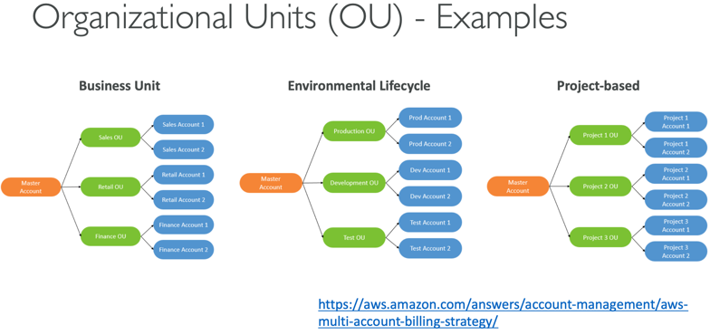 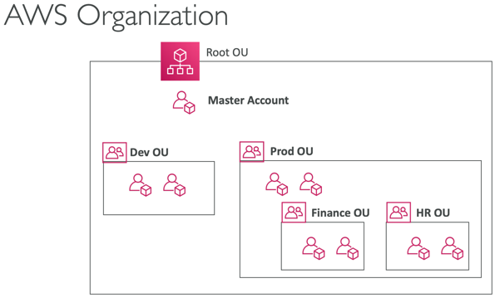

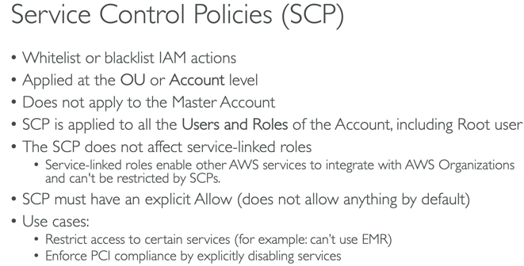 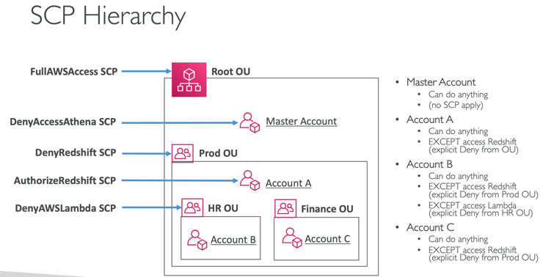

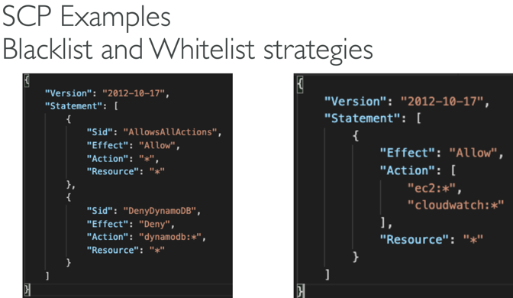 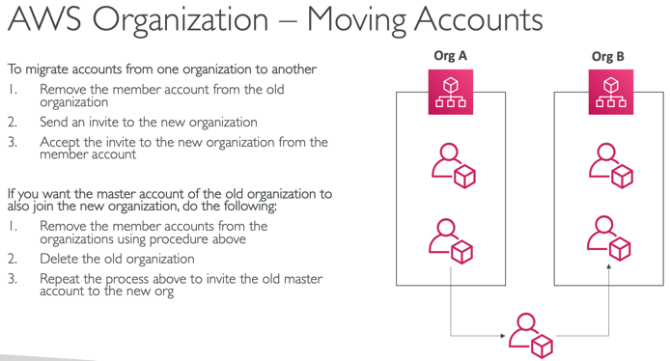

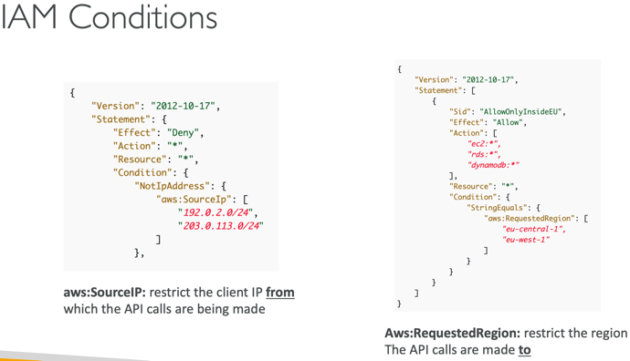 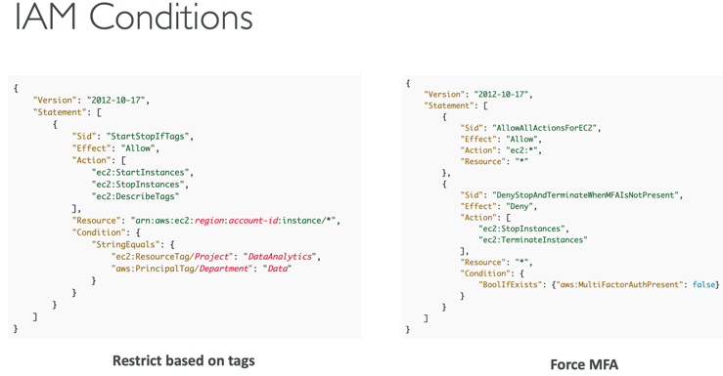

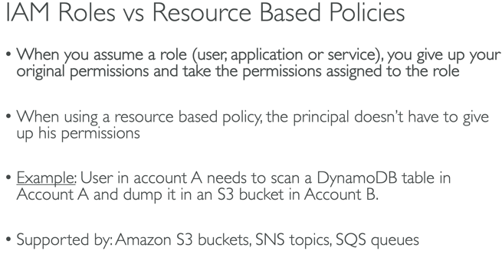 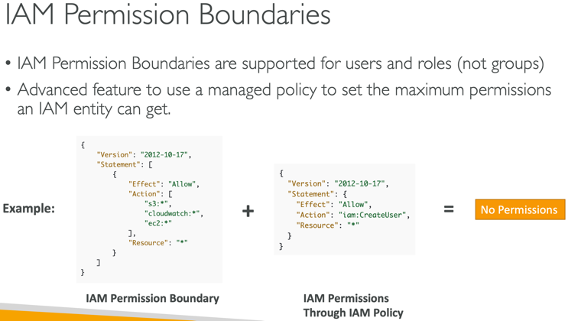

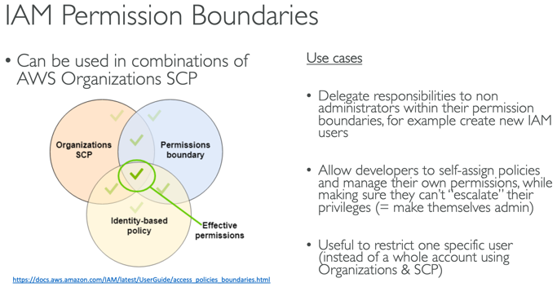 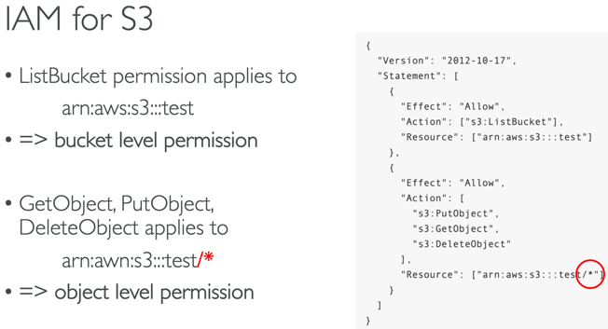

AWS supports permissions boundaries for IAM entities (users or roles), NOT groups.

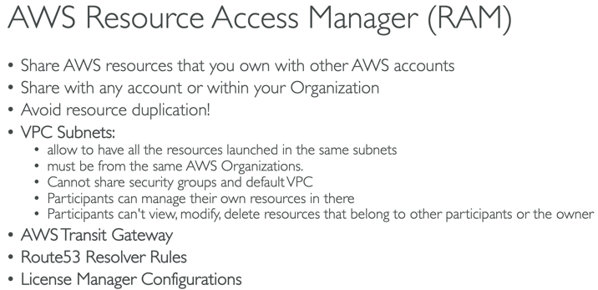 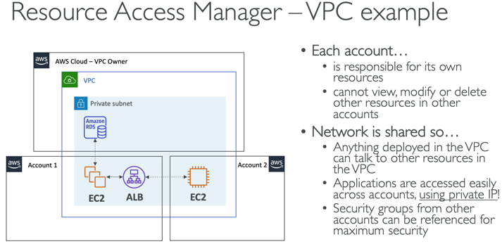

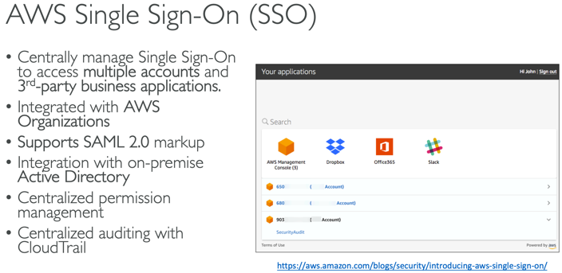 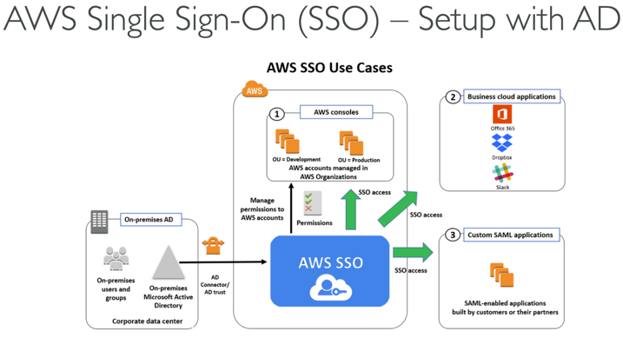

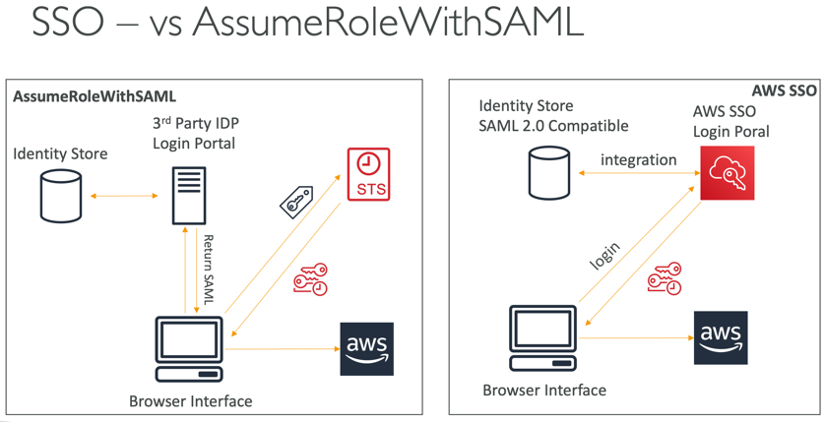 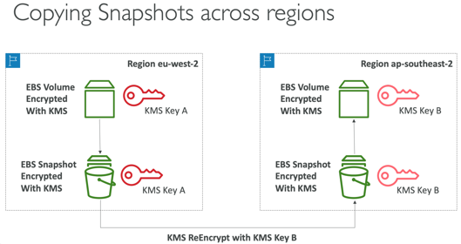

KMS keys can have default (entire account) or custom policies

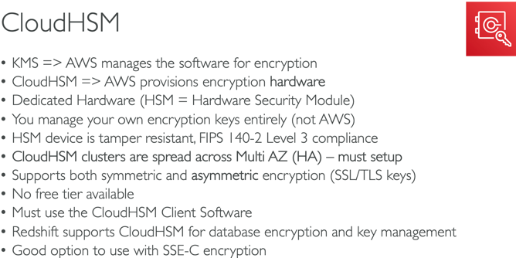 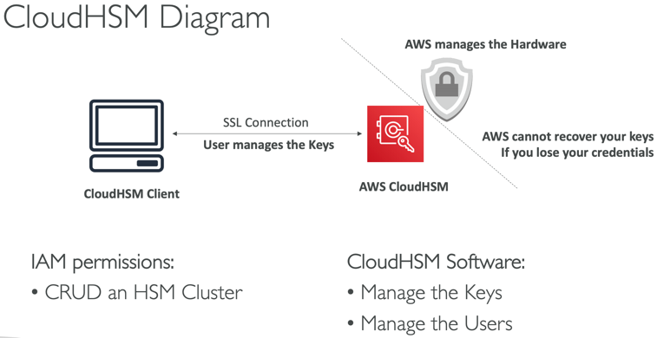

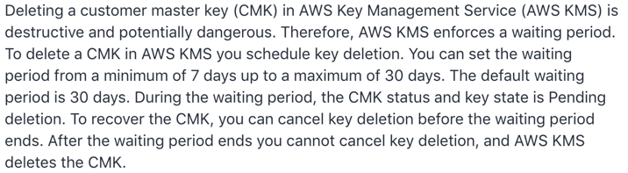

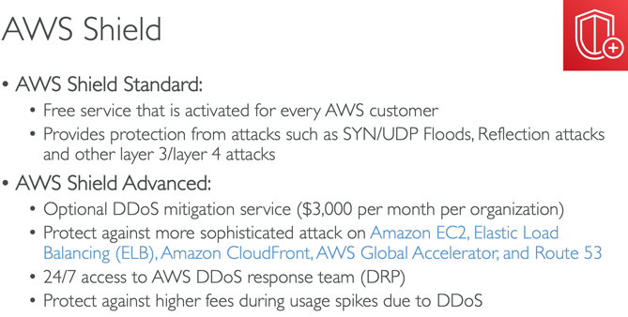 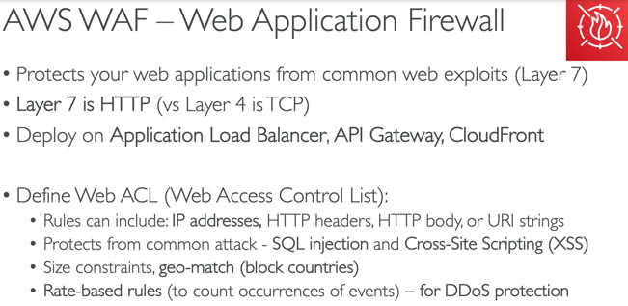

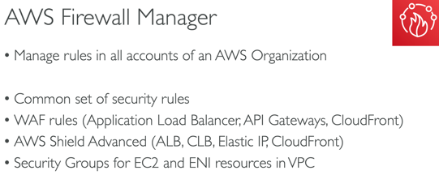 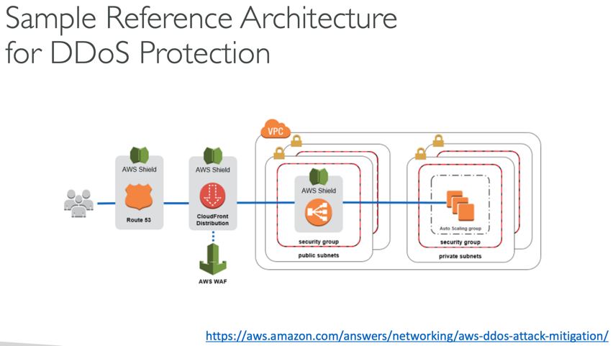

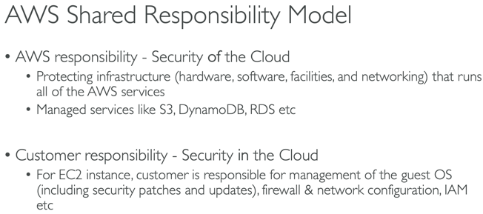 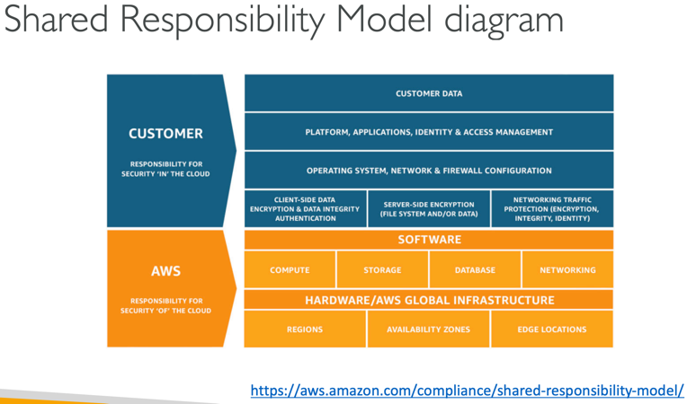

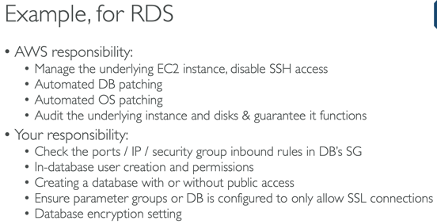 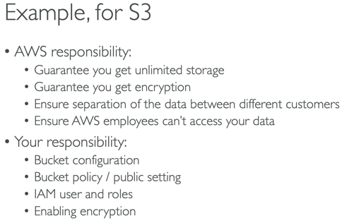

VPC 531-586 <https://media.datacumulus.com/aws-saa/AWS%20Certified%20Solutions%20Architect%20Slides%20v3.4.pdf>

VPC Peering – not transitive

NAT Gateway – ipv4, highly available, AWS managed

Nat Instance – ipv4, security groups needed, support Bastion; disable source/dest flag

Egress Gateway – **ipv6** only, ipv6 instances are publicly accessible; gateway gives instances access to internet but not directly reachable by internet; cannot be used to connect on-premises data centers to AWS Cloud

Gateway Endpoint – S3, DDB

Interface Endpoint – other AWS services

Endpoint Service/PrivateLink – NLB, ENI, expose your services

RAM – cost efficient; vpc sharing

Transit Gateway – resource efficient; star model; regional/cross; support multicast

Direct Connect – physical connection, private, not encrypted, 1 month setup; dedicated and hosted connections; supports ipv4/6

Direct Connect Gateway – setup DC to one or more VPCs in different regions and same acct

Direct Connect + VPN provides an IPsec -encrypted private connection

Site to Site VPN – customer gateway <-> virtual private gateway(vgw); connect on prem to vpc

CloudHub – provide secure connection between sites w/multiple VPN connections

Bastion – SSH connection to VPC private subnets using TCP (port 22) with NLB; located in public

Flow Logs – Cloudwatch Logs or S3; troubleshoot looking for ACTION

<https://docs.aws.amazon.com/vpc/latest/userguide/vpc-nat-comparison.html>

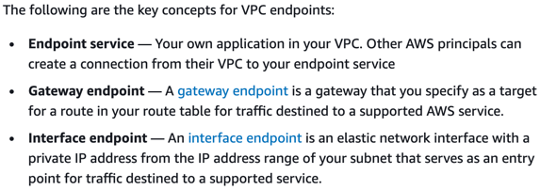

Default NACL allows everything outbound and everything inbound

Newly created NACL will deny everything

NACL – stateless; security group – stateful

NACL – block IPs

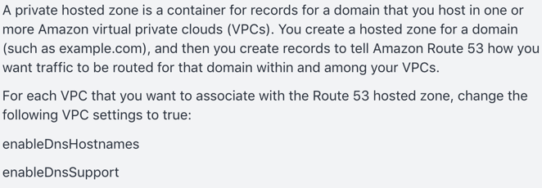 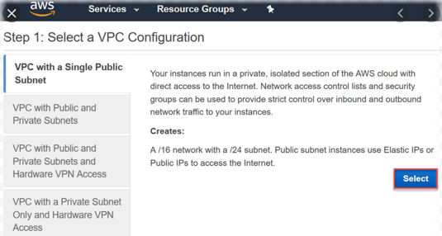

By default, Route 53 Resolver automatically answers DNS queries for local VPC domain names for EC2 instances. You can integrate DNS resolution between Resolver and DNS resolvers on your on-premises network by configuring forwarding rules.

To resolve any DNS queries for resources in the AWS VPC from the on-premises network, you can create an **inbound** endpoint on Route 53 Resolver and then DNS resolvers on the on-premises network can forward DNS queries to Route 53 Resolver via this endpoint.

To resolve DNS queries for any resources in the on-premises network from the AWS VPC, you can create an **outbound** endpoint on Route 53 Resolver and then Route 53 Resolver can conditionally forward queries to resolvers on the on-premises network via this endpoint. To conditionally forward queries, you need to create Resolver rules that specify the domain names for the DNS queries that you want to forward (such as example.com) and the IP addresses of the DNS resolvers on the on-premises network that you want to forward the queries to.

<https://docs.aws.amazon.com/Route53/latest/DeveloperGuide/resolver.html>

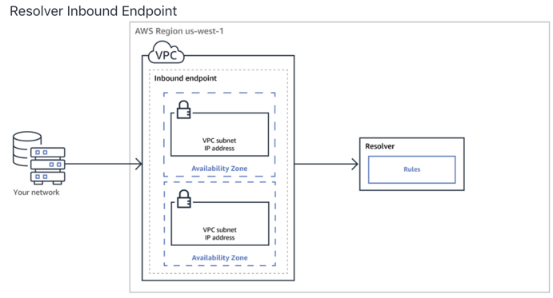 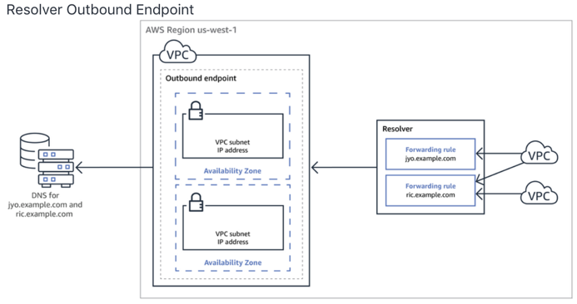

Amazon VPC provides the facility to create an IPsec VPN connection (also known as site-to-site VPN) between remote customer networks and their Amazon VPC over the internet. Create a Virtual Private Gateway on the AWS side of the VPN and a Customer Gateway on the on-premises side of the VPN

An Internet Gateway serves two purposes: to provide a target in your VPC route tables for internet-routable traffic and to perform network address translation (NAT) for instances that have been assigned public IPv4 addresses.

Use **VPC sharing (part of RAM)** to share one or more subnets with other AWS accounts belonging to the same parent organization from AWS Organizations

Disaster Recovery

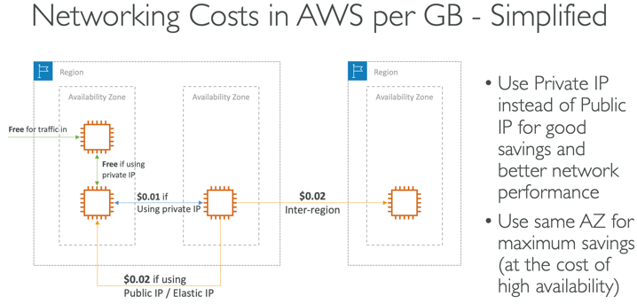 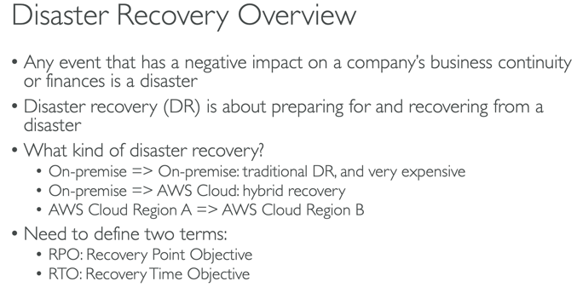

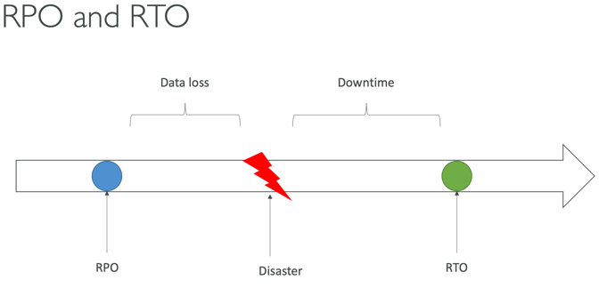 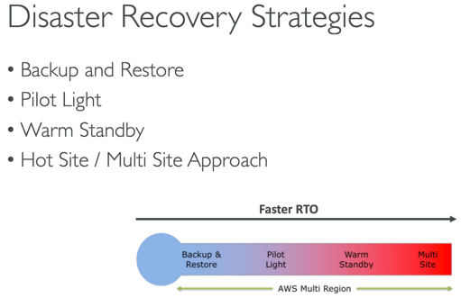

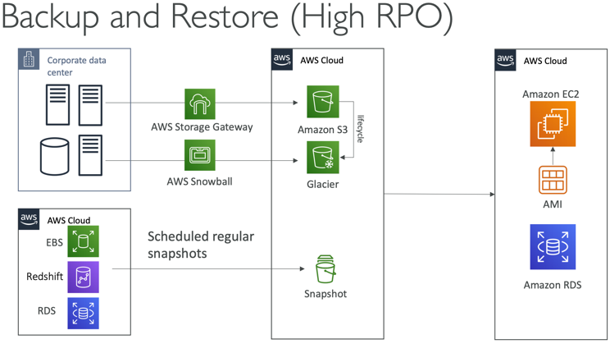 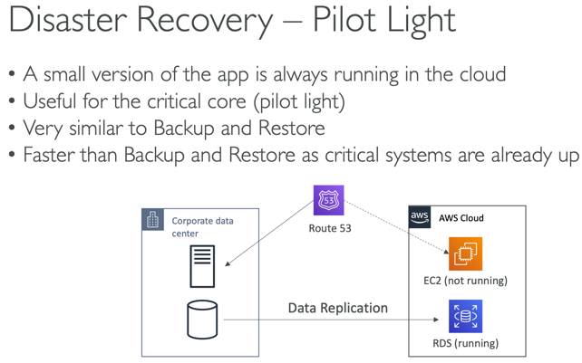

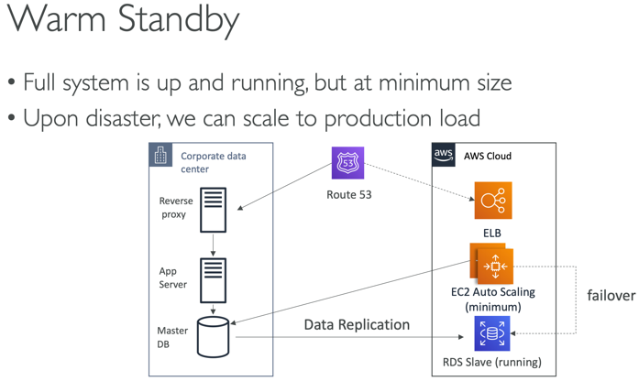 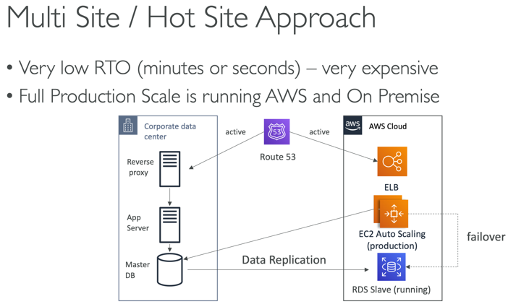

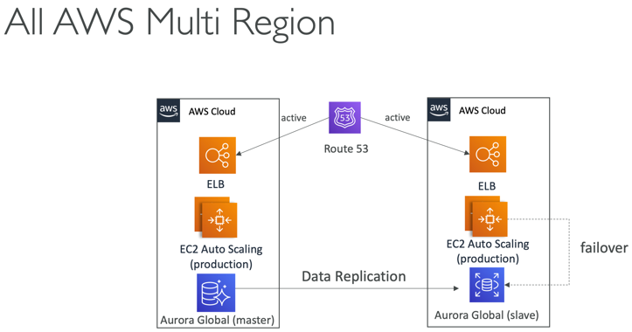 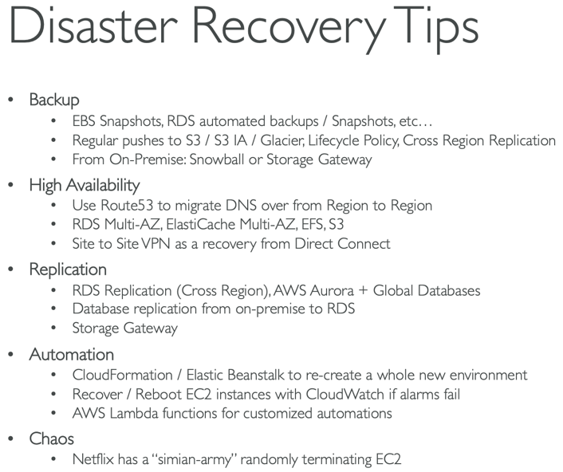

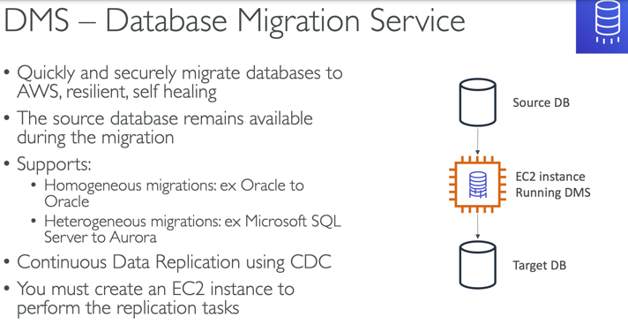 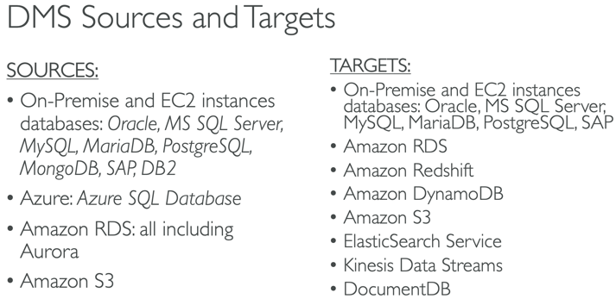

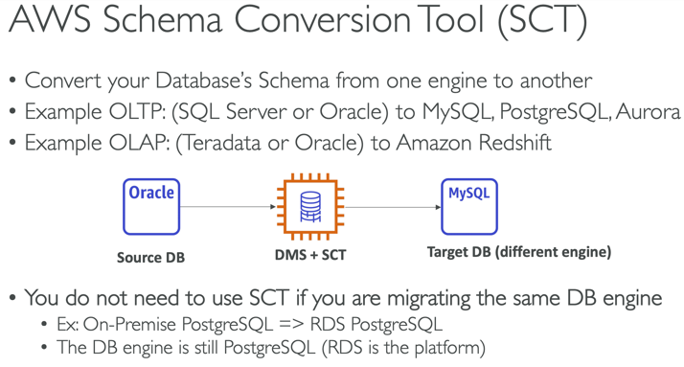 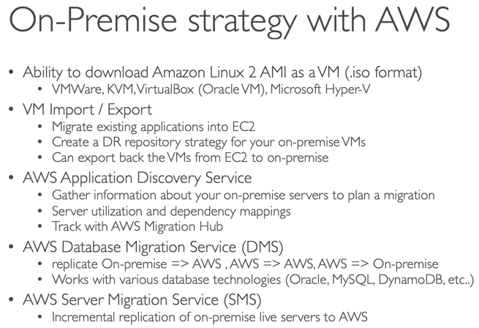

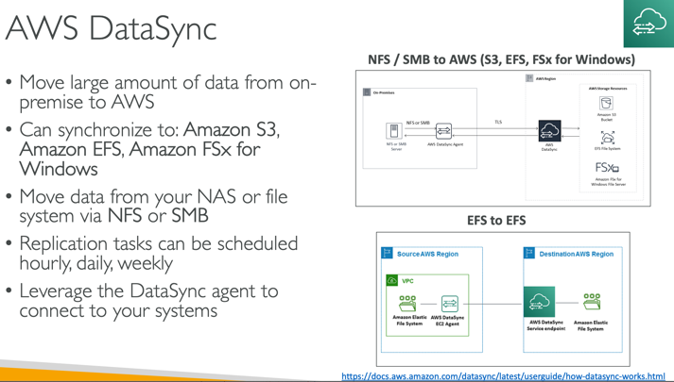

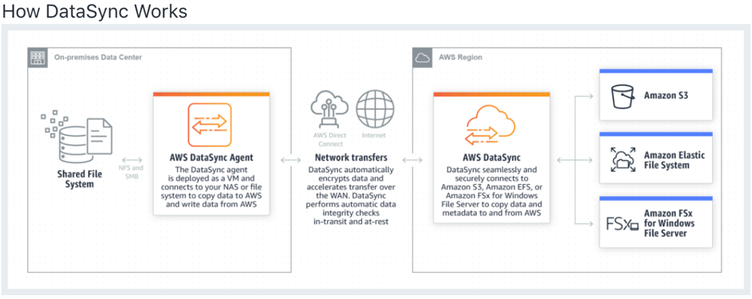

DataSync fully automates and accelerates the data transfer. It comes with retry and network resiliency mechanisms, network optimizations, built-in task scheduling, monitoring via the DataSync API and Console, and CloudWatch metrics, events, and logs that provide granular visibility into the transfer process. DataSync performs data integrity verification both during the transfer and at the end of the transfer.

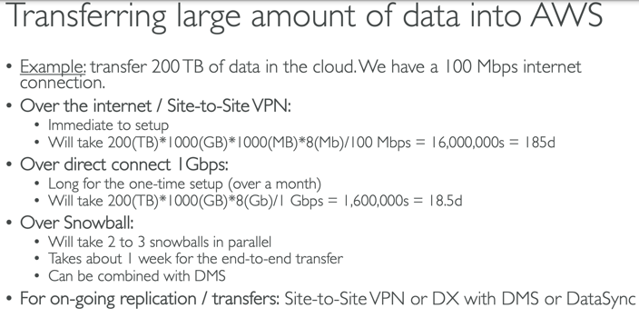

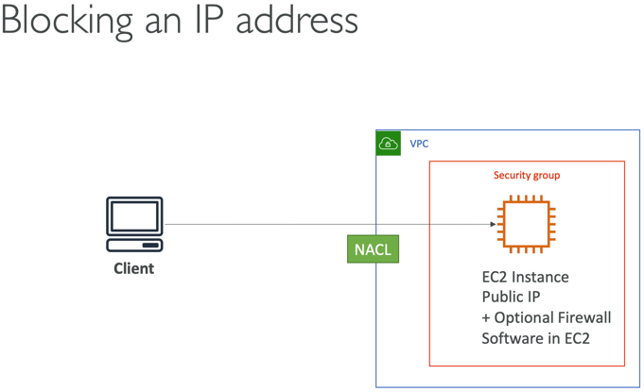 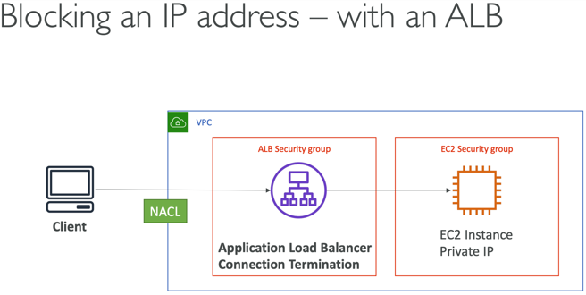

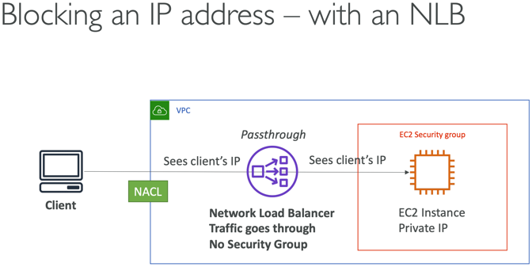 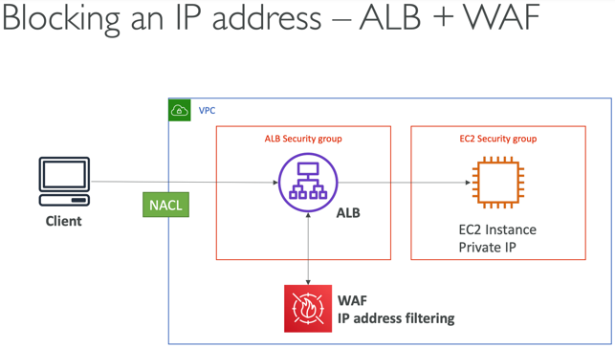

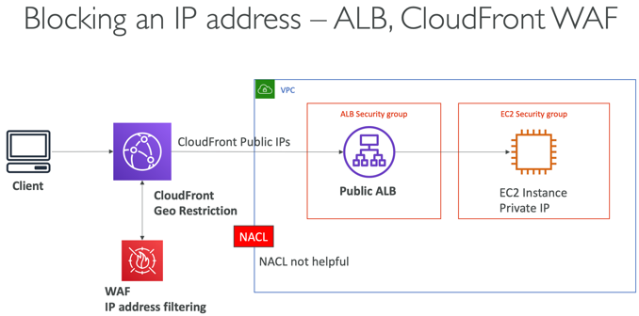

High Performance Computing

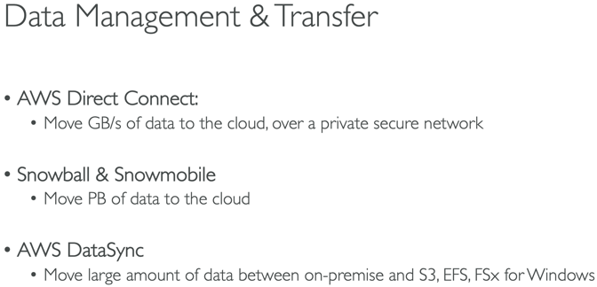 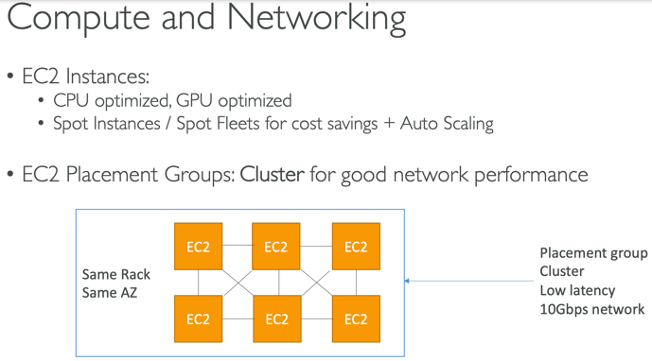

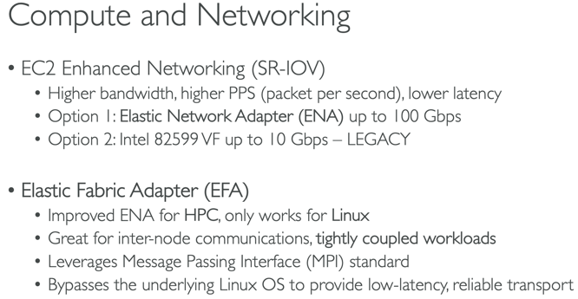 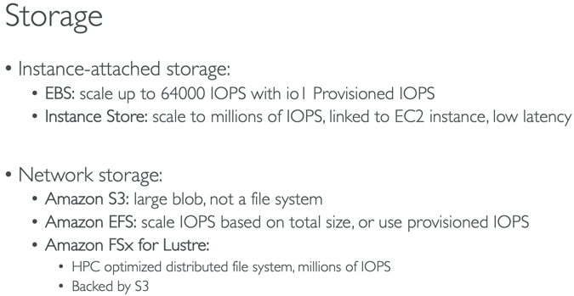

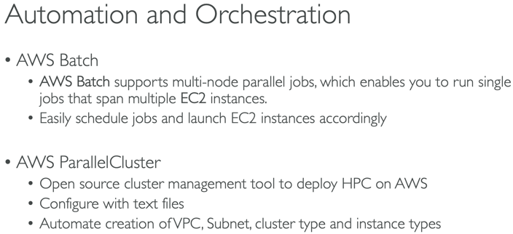

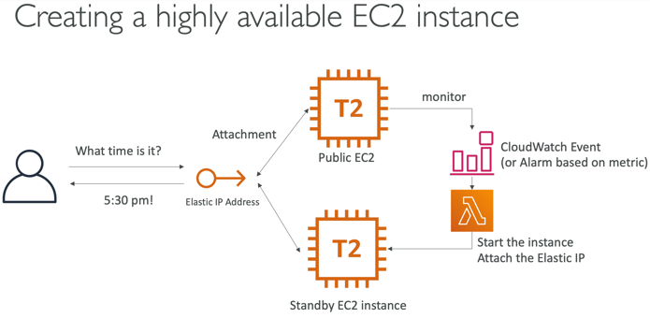 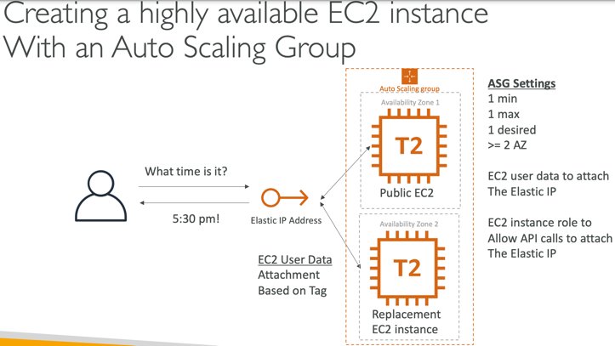

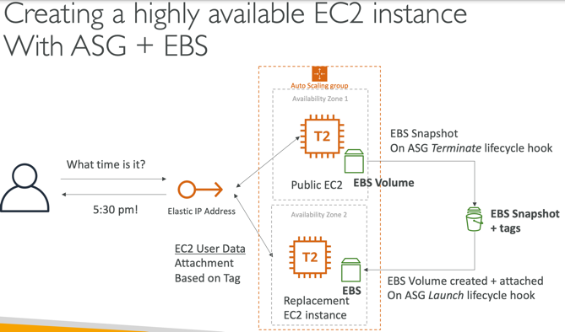 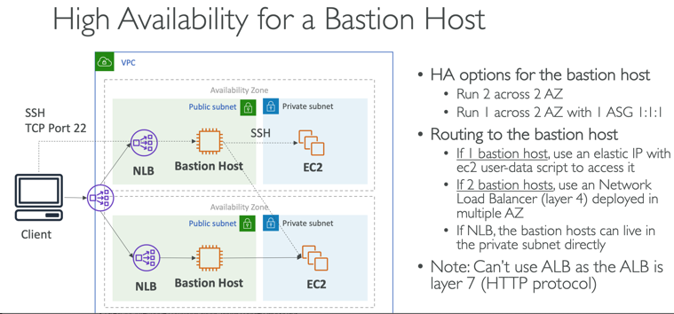

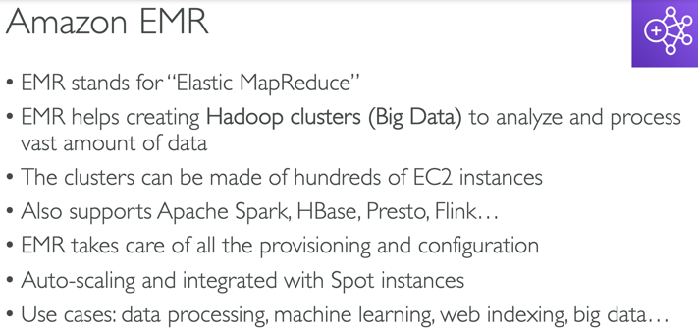 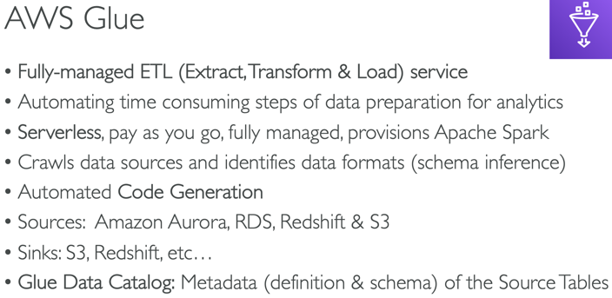

Glue – raw, refined zones

ETL best cost optimization is to have the refined data stored in compressed format via the Glue job.

<https://aws.amazon.com/blogs/apn/turning-data-into-a-key-enterprise-asset-with-a-governed-data-lake-on-aws/>

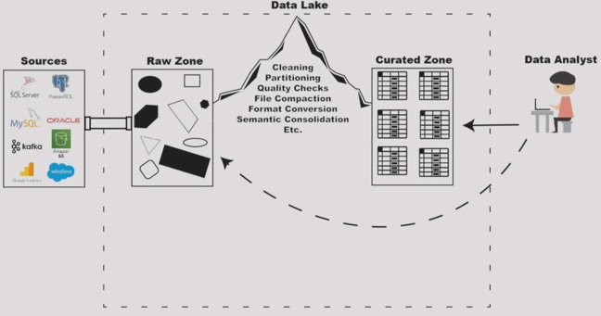

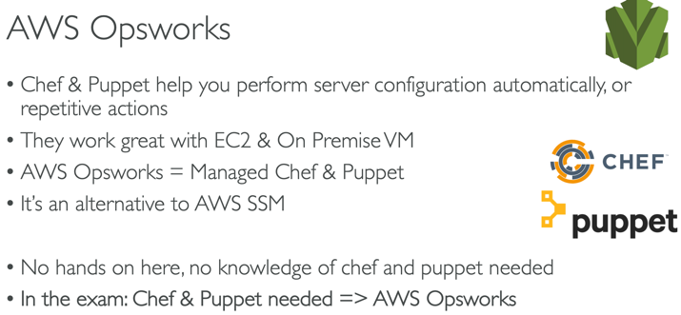 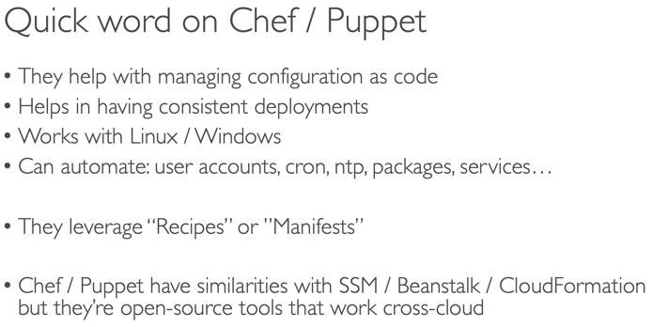

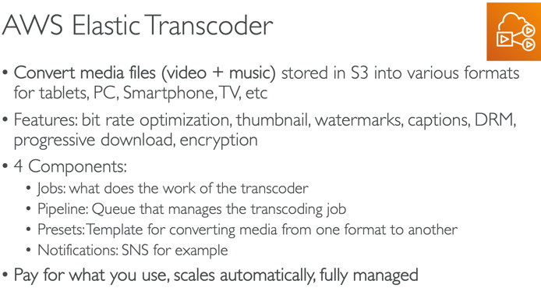 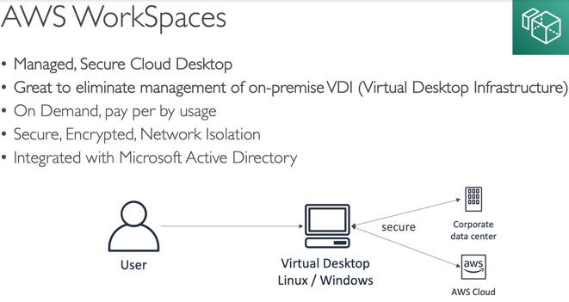

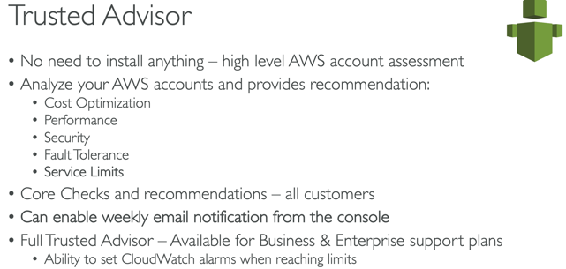

* At the exam I had questions around Data sync vs storage gateway, NAT gateway vs NAT Instance. Had one 1 on API gateway usage plan and Cost explorer. Got no questions on Global Accelerator and Organization. But rest of the questions covered all the areas. I had a couple of tough one around DX + VPC sharing
* A lot of question in the solutions architect exam is now scenario based and almost 4-6 questions were about Dynamo DB - on-demand service and transaction.
* 1. More questions on Snow ball edge and its computations.
* 2. Global accelerator (High availability and performance). Region fail over is the key aspect.
* 3. Lots and lots of questions about S3 - Almost 80%. Some times it is about S3 (or) S3 is involved. Like learn about quick S3 commands like CLI CP Command and Sync command.
* 4. Multi RDS A-Z was promoted a lot.
* 5. Dynamo DB on demand, Transactions was there (I was surprised too).
* 4. Life cycle hooks, S3 tier price, RDS encryption. NAT instance usage in auto scaling to provide HA.
* 5. Policy questions (Sourced IP, how the policy impacts). SCP, Service linked role, Organizations on IAM.
* 6. FIFO queues and Most important it can not be used with SNS topic.
* 7. Aurora Serverless, VPC scenario questions, Dynamo DB, Elastic cache Radis/ mem cached.
* 8. ECS cluster with auto scaling.
* 9. Kinesis fire hose, Streams how can we build HA & fault tolerant systems.
* 10. Windows FX, EFS 4 questions.

EC2 Instance Types: R, C, M, I, G, T2/3

EBS Raid 0, 1

Global: Unicast vs Anycast IP; Global Accelerator vs CloudFront

Snowball, Edge and Snowmobile  
Storage Gateway: File, Volume (cached/stored) and Tape

FSx for Windows vs FSx for Lustre

WAF:

FireWall Manager:

Shield: Standard; Advanced - DDoS

<https://docs.aws.amazon.com/waf/latest/developerguide/what-is-aws-waf.html>

AWS Organization Trail

